**Banking is necessary, banks are not.**

**You can't stop the waves, but you can learn to surf- John Kabat Zinn**

**Your surfing can get better on every turn, on every wave you catch. Learn to read the ocean better. A big part of my success has been wave knowledge." ~ Kelly Slater. 11 times world champion in Surfing**

**When the rate of change outside the organization is greater than the rate of change inside the organization, the end is near-Jack welch**

**Don't tell me that sky's the limit, when there are footprints on the moon.**

It is not the strongest of the species that survives, nor the most intelligent that survives. It is the one that is the most adaptable to change”

Disruption in the end is a shift in power in relationships (Charlene Li)

Who owns the audience, owns the last mile. Closest to customer, closest to disruption.(Sameer Patel)

The success of the integration and convergence of technologies and of technologies as such depends on collaboration in diversity and the empowerment and involvement of people across the board

The future is already here – it's just not evenly distributed.

The Economist, December 4, 2003”

― William Gibson

You are no longer too big to fail

1. Preface
2. Acknowledgement
3. ABSTRACT OF THE PROJECT
4. Contents
5. About NID
6. About SDM
7. PROJECT TIMELINE - Infographic Format?

Preface

The culmination of a student’s journey at the National Institute of the journey is marked by a project that he must undertake in his own discipline of study. It is in an explorative investigation of a subject that has designed as its central theme.

This project, termed as the Graduation Project is an opportunity for them to showcase their learning as an independent designer. This project can be done with an industry or could be self-sponsored with a larger goal to bring about a positive impact on the company, self and society at large. The project is succeeded by a document which provides access to the work to a larger audience keeping in tune with the tradition of learning, does and shares art NID.

The designer needs to be abreast with design principles and practice and should apply them holistically and systematically while striving for creativity and innovation in the pursuit of the objective of this project. It should leave a future scope to generate new information which aligns with the broader objectives of the Institute.

This project aims to understand the current scenarios of digital transformations that the banking industry is undergoing and how can we make digital transformation a success in the face of constantly changing dynamics.

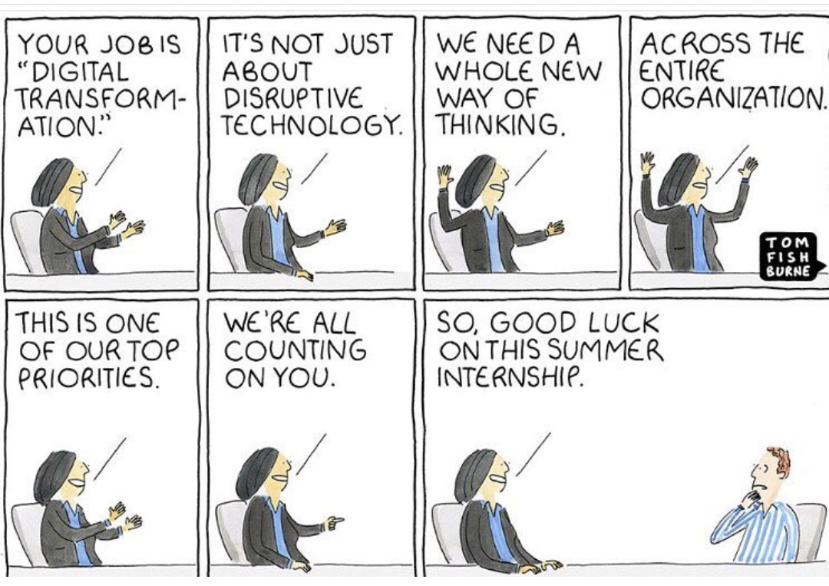

Acknowledgement:

This document reads **Digital transformation for legacy banks** by Pankaj Kumar. What it doesn’t explicitly say and which is what I am taking a moment out to say is that none of this would have been possible without the help and support of a lot of people; people I have grown up with, people I have spent time having conversations, people who have guided and mentored me, places I have travelled and so much more.

To start with, I would like to thank Professor Guruprasad who has been the silent guiding light in my pursuit of this project and my journey at NID. I would like to extend my heartfelt gratitude to Professor Krishnesh Mehta who opened up a world of possibilities to a young boy from North India who came with a zeal to learn and discovered that all I had to do was unlearn.

Next, I would like to thank my team at Societe Generale for the support they extended in seeing this project to fulfilment. A special thanks to my mentor, Mr Praveen Juyal who showed me that a great vision can ignite a storm and there are no limits to what we can achieve.

I would like to thank all my friends at NID and SDM 16 for being my family, my home away from home, for the constant discussions and debates and the strength to see this through.

And last but not the least, I wouldn’t be here if it weren’t the undying faith shown by my parents and family who let a young boy from North India set out on this unknown path of self-discovery.

I thank you all

**About NID:**

The National Institute of Design (NID) is internationally acclaimed as one of the foremost multi-disciplinary institutions in the field of design education and research. The Business Week, USA has listed NID as one of the top 25 European & Asian programmes in the world. The institute functions as an autonomous body under the department of Industrial Policy & Promotion, Ministry of Commerce & Industry, Government of India. NID has been declared ‘Institution of National Importance’ by the Act of Parliament, by virtue of the National Institute of Design Act 2014. On April 7, 1958, the Eameses presented the India Report to the Government of India. The Eames Report defined the underlying spirit that would lead to the founding of NID and beginning of design education in India. The Report recommended a problem-solving design consciousness that linked learning with actual experience and suggested that the designer could be a bridge between tradition and modernity. The Report called upon future designers to re-examine the alternatives of growth available to the country at that time. Based on the recommendations made in the India Report, the Government of India with the assistance of the Ford Foundation and the Sarabhai family established the National Institute of Industrial Design, as it was originally called as an autonomous all-India body in September 1961 at Ahmedabad. NID is recognised by the Dept. of Scientific & Industrial Research (DSIR) under Ministry of Science & Technology, Government of India, as a scientific and industrial design research organisation. NID has been a pioneer in industrial design education after Bauhaus and Ulm in Germany and is known for its pursuit of design excellence to make Designed in India, Made for the World a reality. NID’s graduates have made a mark in key sectors of commerce, industry and social development by taking the role of catalysts and through thought leadership.

NID Gandhinagar is situated in the city of Gandhinagar, in Gujarat. As part of expansion plan, NID has built a new postgraduate campus at Gandhinagar, the capital of Gujarat State. Commerce and Industry Minister Kamal Nath laid the foundation stone for this campus and it consists of a jewellery and automobile design centre along with lifestyle accessory design, new media design, toy and game design, strategic design management, transportation and information design centres.

**About SDM**

In today’s rapidly changing VUCA world, businesses are increasingly required to have the ability to create opportunity out of the ambiguous, tangibility out of the intangible and create worth and wealth out of the constraints. This can only be achieved by the capability and the capacity to continuously contextually reinvent, renovate and ‘design’ their business strategies, processes, tools and techniques. The competitive edge of the enterprises of the future will be dependent on their ability and agility to dynamically steer and realign their modes of operation and further increasingly on their ability to master the intangibles and the multifarious. Basically, organizations will either win or perish based on their ability to detect and deliver to both, the minds and hearts of the consumers by being able to sense and serve not only what is wanted but also forecast and provide what maybe wanted in a way that is biophilic -seeking to improve, evolve and enrich the life and lives rather than just be profit maximising. Businesses today have to be inclusive and holistic and maximise worth and dignity rather than just revenues. Such businesses require leaders who, apart from being entrepreneurial, can adroitly envision and decode the future, simplify the complex and offer enchantment. Such leaders have the ability to design contextually relevant imaginative, creative, transformational and intuitive strategies, business processes, tools and techniques rather than just copy, follow and run the operations. They have the ability to design and make the future present. Management and leadership practices of today are found wanting to meet these requirements and direly need re-imagination. Design as a discipline has been addressing these issues and Strategic Design Management (SDM) is a programme specifically designed powered by design methodologies to meet these demands and fill these gaps. The SDM programme envisages creating professionals who are whole brained and balanced in the heart, head and hands and thereby have the ability to understand and serve from the rural to the urban, local to the global, crafts to corporate, private to public, individual to social, self to culture, proprietary to governmental, logical, sensory to emotional, material to spiritual, across gens BB, X, Y & Z, jobs to entrepreneurship sectors. The curriculum strives to enhance the sensitivity and perceptivity and develop a strong ability to have creative and innovative approaches to looking at life and business processes. SDM is about redefining and redesigning management processes, strategies and leadership paradigms through strategic design interventions.

**About Societe Generale:**

Societe Generale is one of the leading European financial services groups. Based on a diversified and integrated banking model, the Group combines financial strength and proven expertise in innovation with a strategy of sustainable growth, aiming to be the trusted partner for its clients, committed to the positive transformations of society and the economy.  
  
Active in the real economy for over 150 years, with a solid position in Europe and connected to the rest of the world, Societe Generale has over 147,000* members of staff in 67 countries and supports on a daily basis 31 million individual clients, businesses and institutional investors around the world by offering a wide range of advisory services and tailored financial solutions. The Group is built on three complementary core businesses:  
  
**French Retail Banking**, which encompasses the Societe Generale, Crédit du Nord and Boursorama brands. Each offers a full range of financial services with omnichannel products at the cutting edge of digital innovation;  
  
**International Retail Banking**, Insurance and Financial Services to Corporates, with networks in Africa, Russia, Central and Eastern Europe and specialised businesses that are leaders in their markets;  
  
**Global Banking and Investor Solutions**, which offers recognised expertise, key international locations and integrated solutions.

**About Société Générale Global Solution Center**

Société Générale Global Solution Center (SG GSC), a 100% owned subsidiary of European banking major Société Générale (SG), embarked on its Indian journey in 2000, and has displayed remarkable growth since. In 2002, the IT division expanded to include Investment Banking, and the back-office operations were launched in 2004. In 2005, the Infrastructure Management Services division was set up to manage infrastructure remotely for the Corporate and Investment Bank. The year 2007 saw the birth of the Securities Services division. In 2010, the Operations division for CIB came about. The inception of the Accounting and Finance division for the Investment Banking operations followed in 2011.



**Introduction:**

**The context of the project:**

A decade ago, did anyone anticipate that the world’s largest accommodation provider(AirBnB) would not have any own real estate, world’s largest taxi service provider?(Uber) would not have any vehicle, world’s largest online retailer(Amazon) would not have any inventory, world’s largest media company(Facebook) would not produce any content and a 15 year old company(Paypal) would push 100 year old banks to the boundaries?

In today’s dynamic business environment, businesses are constantly facing challenges due to the changing landscape caused by waves of digital disruption, change in customer expectations and increased competition. This disruption in VUCA business environment has dramatically caused a shift in the core business offerings. The origin of the wave of disruption can be divided into three forms.

1. Technology based disruptions: Technology based disruptions are the major form of disruptions. It essentially is fueled by the use of technology in business to improve the technical capabilities. e.g. Mechanical to digital watches
2. Architecture based disruption: Architecture based disruptions are the form of disruptions where we change the basic architecture of the product or service. e.g. Big music players to sony portable walkman
3. Business model Disruption: Business model disruptors find a way to fundamentally change the traditional industry business model and generate growth by innovating in the business model. E.g. traditional hotel to AirBnB

*Referred Digital Transformation course by BCG and University of Virginia

Professor Klaus Schwab mentions says that “The changes are so profound that, from the perspective of human history, there has never been a time of greater promise or potential peril. My concern, however, is that decision-makers are too often caught in traditional, linear (and non-disruptive) thinking or too absorbed by immediate concerns to think strategically about the forces of disruption and innovation shaping our future.”

**The Paradigm shift due to technology:**

Today, we are standing at the brink of the technological revolution that is fundamentally shifting the way we interact, the way we live and the way we work. In its scale, scope and complexity, this would be the colossal shift humankind has experienced before. As of now, we can not speculate the future but considering the multidimensional penetration, we can say that it is going to impact all facets of life.

Looking back, the first profound shift for human civilization came with the agrarian revolution 10,000 years ago. The domestication of animals, coupled with new farming technologies, improved food production, spurred dramatic population growth and led to the rise of fixed settlements. This agrarian revolution was followed around 1780 with the First Industrial Revolution, driven by the rise of steam power, railways and mechanized forms of production. The Second Industrial Revolution took hold in 1870 with the rise of electricity and new approaches to manufacturing based on assembly lines and mass production. The Third Industrial Revolution emerged in the 1960s with the rise of semiconductors and the spread of computers and the internet.

Today, we are facing the fourth Industrial Revolution. Building on the digital technologies of the Third Industrial Revolution, it is powered by a wide range of new breakthroughs. These new technologies are revolutionary due to the speed, breadth and depth of the anticipated change they will bring. It is still difficult to say that the beginning of the fourth revolution was the culmination of the third revolution but surely, humankind is currently witnessing the odyssey of third and fourth revolution. The fourth revolution is not only progressing at an exponential growth but also blurring the lines between physical, digital and biological spheres. The breadth and depth of these changes herald the transformation of entire systems of production, management, and governance.

**Exponential Growth of Technology:**

For the vast majority of human existence, it was safe to assume that the world in which you die would look pretty much the same as the one in which you were born. But that is no longer the case—and pretty soon humans won't even die at all, says futurist Ray Kurzweil. "**We won’t experience 100 years of progress in the 21st century — it will be more like 20,000 years of progress (at today’s rate)**," wrote Kurzweil in 2001. Just think about how much things have changed in the past 10 years—wireless internet, smartphones, Facebook and Twitter—and then try to imagine how vastly different things will be in 2021, or even 2100.

To get a fair idea about the computational capabilities today,  **a simple smartphone or a pocket calculator has more computing power than the first moon mission.** This phenomenon of multidirectional disruption by technology can be referred as the amplifying loop of technological progress. Technology evolves fast, even faster than what the human intuition can capture. The exponential growth of technology is the resultant of the three fundamental laws namely, Moore’s, Butters and Kryder acting simultaneously.

**Moore’s Law:** The number of transistors in a densely integrated circuit doubles about every two years

**Butter’s Law:** Data transmission over a fibre optic cable doubles every nine months

**Kryder’s Law:** Doubling of disk density on one inch of magnetic storage would take place once every thirteen months

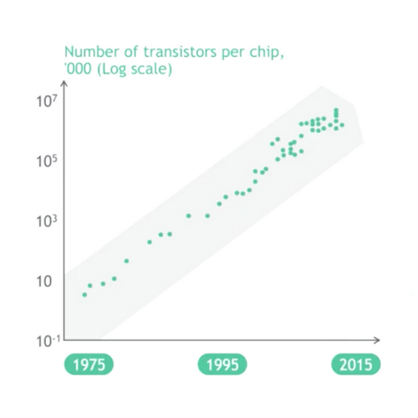

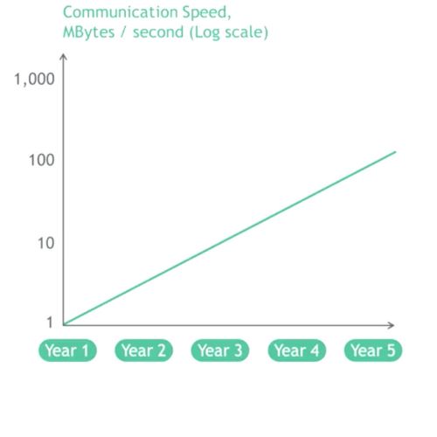

**Timeline for companies with respect to evolution of technology**

1. Casio disrupted analogue watch making business by making digital watches
2. IBM disrupted Business machine industry by pivoting with pc against typewriters and replaced Remington which has 80% market share in typewriter business
3. Nikon and Canon replaced market leader Kodak by replacing film camera with working on lense technology and developing a robust digital camera
4. Music industry was disrupted by napster, pandora and replaced cassette and CD industry
5. Apple came at a very late stage but disrupted Phone industry and redefined industry by creating a balance between technology and design and ultimately thriving in market by almost replacing Nokia and other brands(Hence technology does not remain the only differentiator)
6. Netflix and other streaming services replaced blockbusters((60k stores) by totally disrupting movie business

**Disruption in Banking:**

Traditionally, Banks have been playing a major role in terms of contributing to the economy of the country. Banks play an important role in the economy as they operate the payment system, the major source of credit for large swathes of the economy, and (usually) act as a safe haven for depositors’ funds. They also encompasses the provision of banking and financial products to consumers and small businesses. In doing so, banks are highly dependent on interest rates, fees and proprietary products.

The Financial Services industry is on a testing journey. Interest rates are stuck in the slow lane, mobile apps are overtaking branches, and most banks cannot outpace the regulatory changes affecting multiple areas; from knowing their local customers, to the global challenges facing their FX, Credit and Risk lines of business. Below is a detailed description of some of the major forces which are currently shaping banking industry.

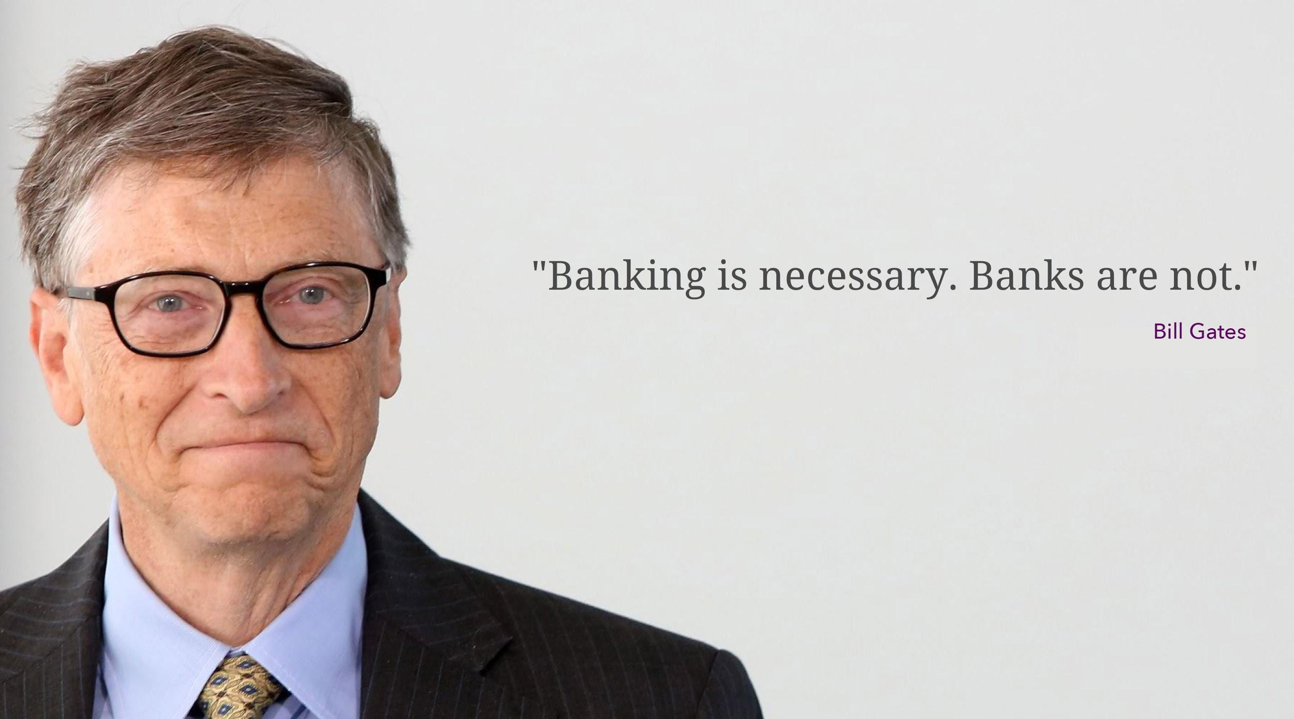

**Structural trends shaping Fintech Industry:**

1. **Wave of Digital Disruption**: The way digitalization has absolutely changed the rule of the industry and banking sector could not come unscathed from the storm of digital disruption. Today, the digital disruption has shaken the core revenue model of banks, as technological revolution has brought architectural changes in value chain of banks, which has ultimately compelled banks to drastically reduce the transaction cost.

***85% of bankers agree that bank industry boundaries are being erased and new paradigms are emerging with every industry being significantly impacted.***

https://www.accenture.com/t20180705T112942Z__w__/us-en/_acnmedia/PDF-20/Accenture-Banking-Tech-Vision-Predictable-Disruption.pdf

1. **Increased Regulatory Demands**: From the financial crisis in 2009 onwards, the time for banks to change was accelerated because of compliance issues. Banking sector today finds itself in pressure due to troublesome regulations to comply with, like Laundering Directive, Market Abuse Regulation and the EU-US Privacy Shield. To fulfill regulatory requirements, banks have internal and external reporting processes which processes raw bank’s data to inform regulators, investors, employee about the bank adhering to the compliances. Efficient reporting allows the reallocation of resources for revenue growth. Poor reporting sends a signal to the regulators to widen their investigations. The risk of penalties ties up significant amounts in contingency funds – up to €8.6 billion for one global, high-street bank. This figure is nearly a sixth of the international banking centre, Luxembourg’s, GDP at €51.86 billion. Regulations like GDPR require proof of the data integrity of personal information and achieving this is not possible for many banks today using their existing processes. In an industry where financial penalties are highly probable and jail time scarily realistic, it’s better to embark on a safer route.
2. **Changes in customer behaviors and dynamics:** In the digital age of hyper connectedness, customers have not remain customers only, they have become customer networks. The smartphone and digital technology is the foundation of today’s increasingly demanding connected consumer. Nothing has changed consumer behavior so much, so fast, as the 24/7/365 connectivity of the smartphone. It allows consumers to shop, search, share, and interact with almost any company and person in the developed world. It also can help consumers make decisions and connect with an increasing number of devices around. Today, Digital natives are demanding the higher customer experience than ever before. In a world of social media, a small unpleasant experience can tarnish the image of any organization, no matter how big the company is. Hence, in such a critical sector like bank, where trust in bank is of paramount importance, having a clean image with excellent customer experience becomes imperative.
3. **Globalization and Offshoring**: When globalization is used in an economic context it refers to the reduction and removal of barriers between national borders in order to facilitate the flow of goods, capital, services and labour. Specifically in context of banking, the advent of internet have blurred geographical boundaries. Also, with the rising workforce distribution across different geographies and availability of cheaper workforce in developing countries like India, China and Vietnam , banks are heavily investing in offshore development centres. It has not only helped banks in supporting their back office functions but also gave them an edge to focus on another customer facing aspects of banking. Though banks are expanding their operations in other markets, they have to adhere to the regulations, compliances and also have to keep cultural considerations in mind pertaining to that market.
4. **Entry of fintech startups:** Government and regulatory authorities are increasing regulation in traditional banking structure and at the same time slacking the requirement for new players to enter in finance market**.** Fintech are not only making impacts on local market but trying capture global markets going beyond the continents. Monzo and Revolut announced it was going into the U.S. market, while going in the opposite direction, the U.S. firm Robinhood is disembarking in Europe. Fintech has already brought unprecedented disruption in the financial services ecosystem. While traditionally, fintech was used for back office functions by leveraging software to help banks manage customer databases, execute transactions and handle accounts, today it has DIY modes where customers rely less on a brick and mortar bank for their banking needs, and instead have a multitude of digital channels at their disposal. With 24/7 device-agnostic access, virtually every transaction is now digitally possible.

Globally, nearly $23 billion of venture capital and growth equity has been deployed to fintechs over the past five years, and this number is growing quickly: $12.2 billion was deployed in 2014 alone and today in 2018 it has reached upto $40 billion by a CAGR of around 18%.

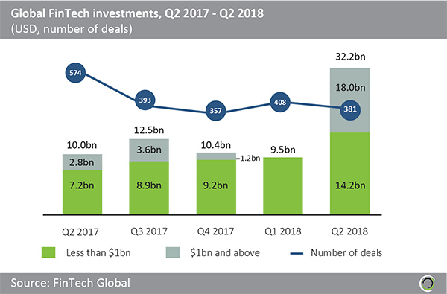

**The holy grail for banks is to become the best at ‘fintegration’.**

**Andres Wolberg-Stok, Global Head of Emerging Platforms and Services at Citibank**

1. **Sticky cost base :** Incumbent operating in finance sphere from more than 100 years have been continuously trying to reduce the operational expenses and achieve higher efficiency. However, traditional ways of operating in multiple layers have been one of road blocker for banks. In comparison to latest entrants, these banks have higher operational expenses in activities like managing brick and mortar model, digitalization of existing process and documents into effective and efficient ways.
2. **Blockchain**: Traditionally banks have been acting as an intermediary between sender and receiver in a typical transaction economy. The core models and functions of a bank is to store, transfer, receive, send, and process payments. Blockchain, a distributed leger will eliminate the need to approve transactions between consumers, blockchain technology could push forward faster payments at lower fees than traditional banking technologies. Blockchain is still currently in its early days of growth. It is still slowly being adopted by average consumers and the traditional banking industry, but it is here to stay.  
   Most people believe that blockchain will eventually take over and disrupt the entire banking industry. Some others believe that blockchain will just be a “support” and an addition to current traditional banking solutions. Regardless of which path blockchain ends up on, we will see an impact and change in the banking industry with upcoming blockchain solutions.

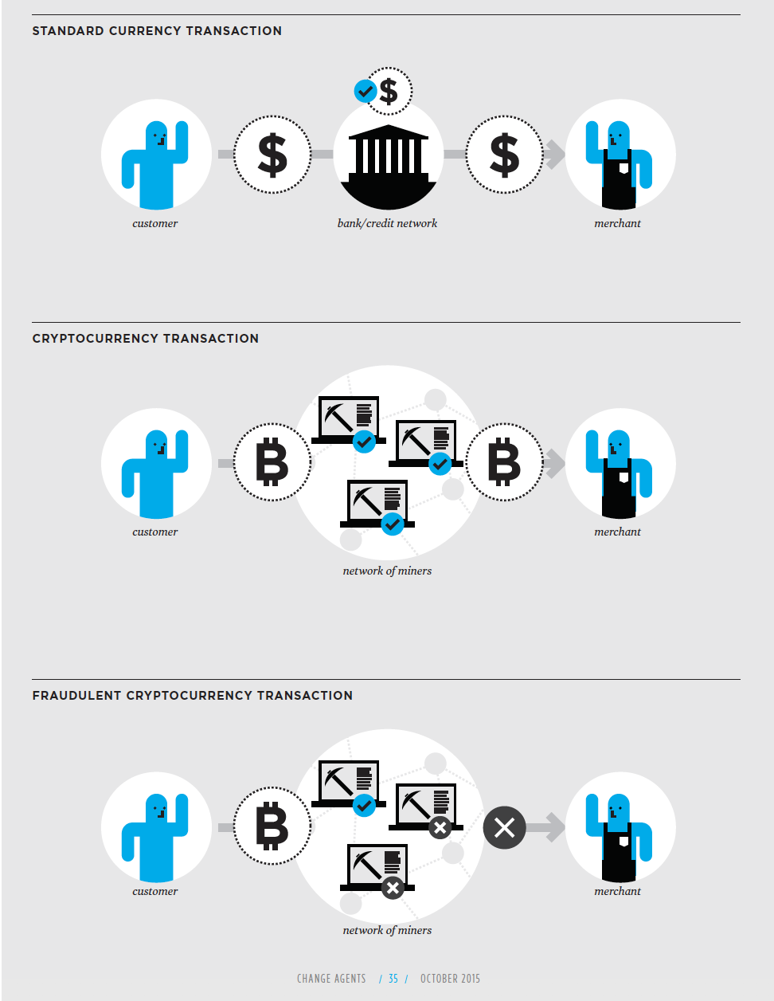

**The Insurgency**:

“Disruption” might sound a cliché term, but it’s hard to find a better word to describe the forces at work today. Among other forms of disruptions, digital disruption is the top-of-mind technological issue in the C-suite today. Senior executives in virtually every industry are wondering whether their firm will be Amazoned or Ubered. Others take a more nuanced view that new digital players might skim off their best customers or steal a share from their most profitable product lines. All are trying to determine whether they should ignore, acquire, partner or compete with their new technology-driven competitors. One of the most publicised disruptive challenges is the one posed to the multi-trillion dollar banking industry From the startup insurgency rattling the foundations of business to a stagnating global economy to the political upheavals that have challenged decades of accepted wisdom, corporate leaders are facing deep uncertainties. **This trend highlights a governing truth: the digital age rewards change and punishes stasis**. But change comes in many flavors. Incremental adjustments or experiments at the periphery, for example, can provide real benefits and, in many cases, are a crucial first step for a digital transformation. But if these initiatives don’t lead to more profound changes to the main business or avoid the real work of re-architecting how the business makes money, the benefits can be fleeting. Companies must be open to radical reinvention, which is a rethinking of the business itself. It requires companies to reexamine, recalibrate and in many cases re-architect their core capabilities to find new, significant and sustainable sources of revenue. How successful companies will be in transforming their core could be the difference between victim and victor in the digital age.

Digital disruption is the top-of-mind technological issue in the C-suite today. Senior executives in virtually every industry are wondering whether their firm will be Amazoned or Ubered. Others take a more nuanced view that new digital players might skim off their best customers or steal a share from their most profitable product lines. All are trying to determine whether they should ignore, acquire, partner or compete with their new technology-driven competitors. One of the most publicised disruptive challenges is the one posed to the multi-trillion dollar banking industry by financial technology upstarts, known as “Fintech”. More than $25bn has been poured into Fintech in the past five years, making it the number-one target for venture funding. An estimated 4,000 firms are challenging banks in every product line in their 1 For the purposes of this research, banking is defined as retail banking plus lending to small business. As Jamie Dimon, CEO of J.P. Morgan told his shareholders about Fintech: “They all want to eat our lunch. Every single one of them is going to try.” Although it accounts for less than 2% of the market, Fintech has its share of hype and promotion.

Indeed, the pace of change caused by digital disruption is still increasing. In Brett King’s book, ‘Banking 3.0’, he chooses a level of 50 million users as the definition of a target figure for a market. For planes and cars to reach this level took over 60 years. Credit cards took 28 years but more recently, contactless credit cards took only four years to reach 50 million users. The following infographic gives us a clear idea about the severity of the situation not only in banking but for most of the industries.

https://www.smartinsights.com/internet-marketing-statistics/happens-online-60-seconds/

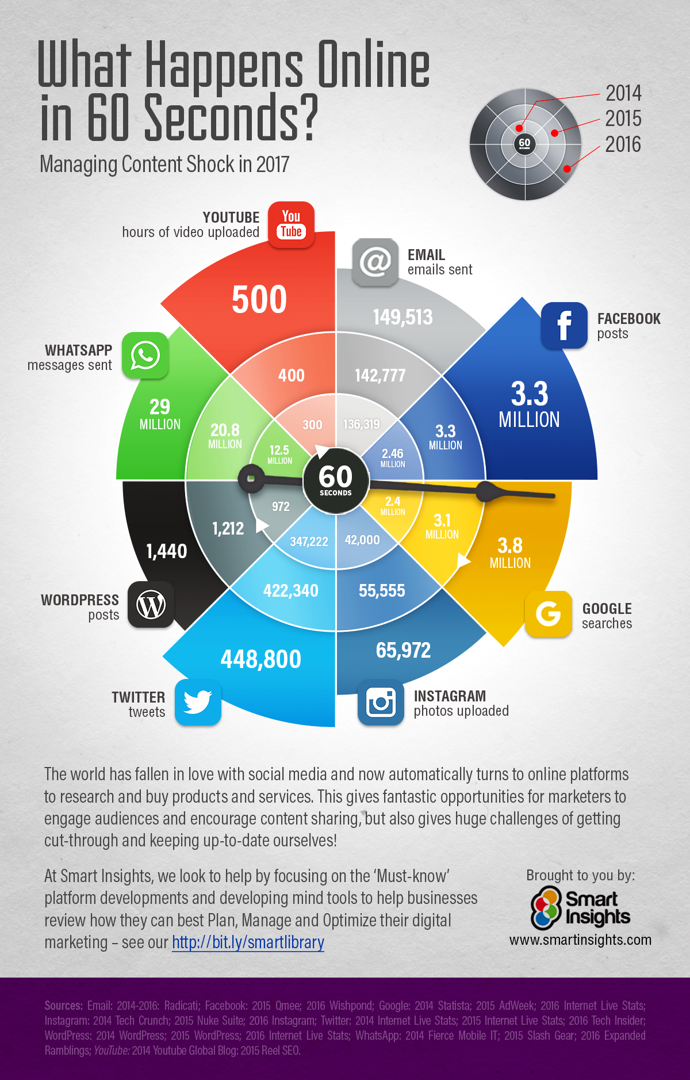

So, the pace of change is getting much faster and the financial services industry has to adapt, if banks are to succeed and survive. If banks want to thrive in future than banks must embrace the current scenario and prepare for the battle. Most of the incumbent and legacy banks are currently finding the routes to maneuver through this bumpy and rough crest. If someone is seeking answers from the industry expert or academia experts, they’ll be give the Digital Transformation as the elixir, which will help the banks in crossing the chasm. The exponential growth of technology has created a state of restlessness among the larger corporate as it is very difficult to drive legacy organizations which have a very high inertia. Though few banks are trying to match the pace by changing their business strategies and focusing more on digital however it seems to be a far fetched dreams currently. The rapid growth of technology and the plodding corporate response has created a huge void.

**When the rate of change outside the organization is greater than the rate of change inside the organization, the end is near-Jack welch**

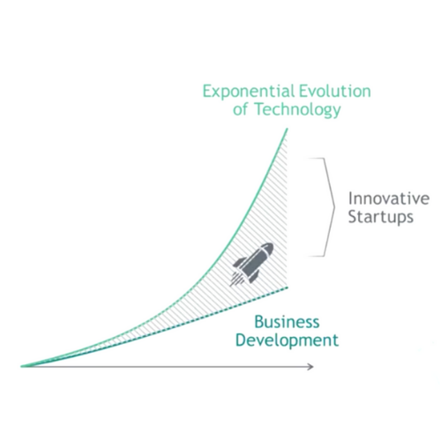

Highlights:

1. Recent trends in banking are reshaping the fundamental banking structure and the ecosystem around it.
2. We underestimate the exponential growth and the impact of technology due to optimistic bias.
3. The crossroads for banks being laid rather precariously at the intersection of three powerful winds of change: Technology, Regulations and Macro developments (mainly sluggish growth and low-for-long rates)

**History of Banking:**

The history of the banking system can be traced back to the Vedic period. The book of Manu has references for deposits of advances, pledge policy of loans and rate of interest. Chanakya had mentioned the existence of powerful guilds of merchant bankers who received deposits, used to issue Hundis and advance loans, around 300 BC in his book Arthashastra.

Banking is also considered to be the “One of the oldest profession”. The history of bank is rich in product diversity, international scope, and, above all, continuous change and adaptation. Generally, change has been required to adjust to shifting economic and regulatory conditions, which have on many occasions been drastic. On such occasions banks have collapsed, only to be replaced by others eager to try their hand in this traditionally dangerous but profitable business. New competitors have continually appeared on the scene, especially during periods of rapid economic growth, opportunity, and comparatively light governmental interference. Competitive changes have forced adaptations, too, and in general have improved the level and efficiency of services offered to clients, thereby increasing transactional volume. **The one constant in the long history of banking is, perhaps, the sight of new stars rising and old ones setting.**

**Let's take a look at the evolution of the money and banking.**

**From Barter to Bitcoin:**Evolution of money:

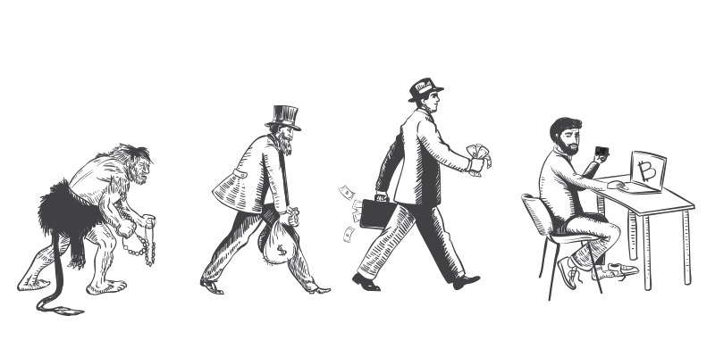

In stone age days human used to rely on barter system to trade where goods were exchanged for goods. Gradually money came into existence which carried certain values and got accepted as a payment medium for transacting an goods and services. It was adopted as a legal tender(currency) within any country to be used in any market.

<https://blog.cryptopay.me/bitcoin-is-still-in-its-very-early-days-like-the-top-of-the-first-inning-in-a-nine-inning-baseball-game/>

<https://www.pinterest.com/pin/628955904180493809/>

**Major Events in the history Banking:**

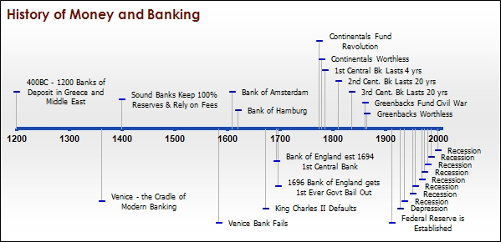

Vedic Period: Around 600 BC

Indian system of trade

Greece unofficial Bank : Around 400 BC

Goldsmiths established first bank of deposits

Banks of Deposit : Around 1200 AD

Damascus and later in Barcelona

The Bank of Venice: Around 1361 AD

Considered to be the first Bank

The Bank of Hamburg  
  
The Bank England

The Rothschild  
  
America & Central Banking: Around 1775

**The 1st Central Bank - The Bank of North America, 1781-1785  
  
The 2nd Central Bank - The Bank of the United States, 1791-1811  
  
The 3rd Central Bank - The Second Bank of the United States, 1816-1836**

**The Panic of 1907: The collapse in shares of a copper trust  
  
The 4th Central Bank - The Federal Reserve: 1913**

The Great Depression 1929

1950 The credit card   
  
1967 The ATM  
  
1973 FTP (file transfer protocol)   
  
1980 Electronic cash counters

1983 Net Banking  
  
1989 Tablet computers

1998 PayPal

2003 Smart Phone

2004 Digital cheque clearing

2009 Blockchain  
  
2010 Mobile and Internet Banking

2015 Blockchain goes mainstream

**A. Barter Exchange System :**  
Barter system is an age old practice and its history dates back to 6000 BC Introduced by Mesopotamia tribes and well adopted by Phoenicians where they traded goods across cities and oceans.  
Bartering was officially first recorded in Egypt in 9000 B.C., when farmers would go to market to exchange cows for sheep, with grains passing through the hands of harvesters in exchange for oils.  
Barter is a system of exchange where goods or services are directly exchanged for other goods or services with mutual consent on the value of goods, by the people(Parties) involved.  
In 1930 during Great Depression it became more popular and specially was used to exchange eatables. Group of Peoples involved used to act more like a banking system, where any of owners items when sold, used to get credited and buyer’s account used to get debited.

**B. Gift Based Economy :**  
A gifting based system was mainly governed by social system where the people gifts people some goods or services without expecting any immediate or future rewards explicitly . It was more like a social values & custom based economy where people exchanged goods on particular events and considered it as relationship building kind of investment. It is prevalent in this modern age too. Some consider the gifts to be a form of reciprocal altruism

**How Money came into existence:**

When agriculture became mainstream in 9000–6000 BCE , both livestock and plant products were used as money.

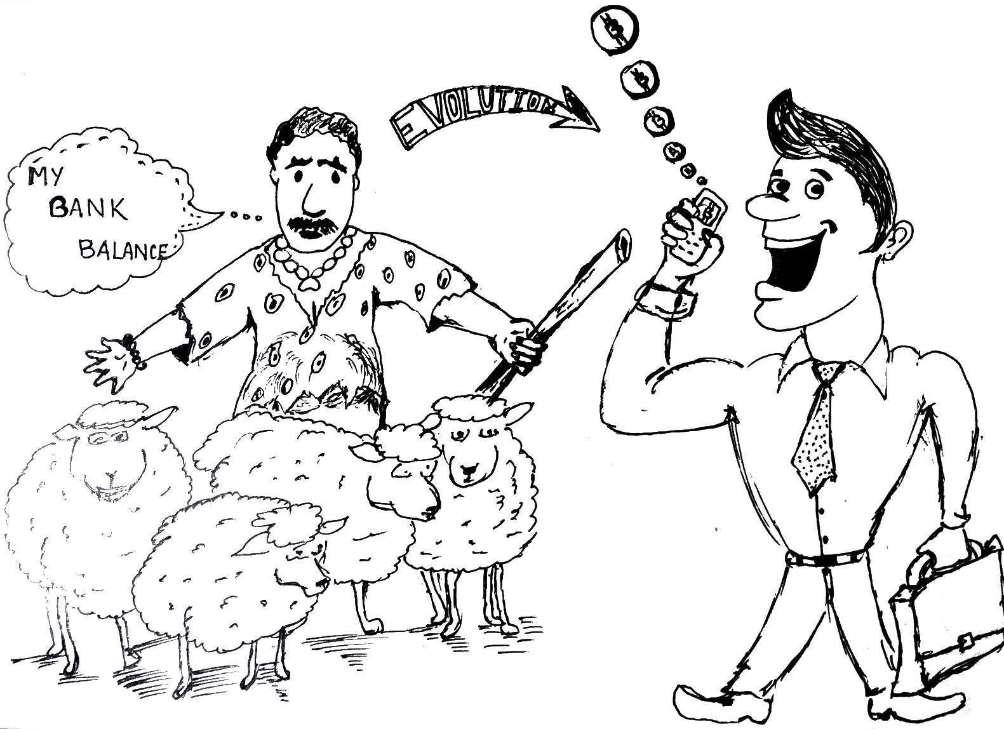

There is a remarkable statement by Aristotle where he spoke why money got created he said :  
  
“*When the inhabitants of one country became more dependent on those of another, and they imported what they needed, and exported what they had too much of, money necessarily came into use”*

**Money has a long history from Bronze age to the current 21st century”**

1. **Bronze Age :**  
Bronze age was more a kind of Commodity Money an objects that have value in themselves as well as value in their use as money. Shekel was used by Mesopotamian, ancient china, africa & india used cowry shells.  
  
2. **Coin Age :**  
Coins were an evolution of “currency” systems of the Late Bronze Age, where standard-sized ingots, and tokens such as knife money, were used to store and transfer value. Indian coins were a kind of punched metal and Chinese were a casted bronze with holes in the center.  
Most coins(currency in modern term) currently are made of a base metal and their value is decided based on the country and its marketplace demand and supply needs, the value of the coin is decreed by government law and thus is determined by the free market only in as much as national currencies are used in domestic trade and also traded internationally on foreign exchange markets.  
  
3. **Bank Notes :**  
The paper based money came into existence in china and majorly was popularised by Song Dynasty in 11th century but the real development happened in 17th century for bank notes when Tang Dynasty(618–907)who used it as merchant receipts to avoid heavy and bulk of coinage, credit notes were used to trade which had certain timeframe and certain discounts.  
The use of banknotes issued by private commercial banks as legal tender has gradually been replaced by the issuance of bank notes authorised and controlled by national governments.  
  
Currently as we are living in 21st century we mostly use currency ( Bank Notes+ Coins) which is issued and governed by government.  
  
**Bitcoin : Age of Cryptocurrency: Money Refined**

Bitcoin is a digital currency of 21st century, It’s a cryptocurrency now accepted worldwide especially in digital payment systems. The Digital currency (Bitcoin) uses a system which is peer-to-peer, and where transactions take place between users directly, without any intermediary. These transactions are verified by network nodes and recorded in a public distributed ledger called a blockchain. Bitcoin was first invented by a Satoshi Nakamoto as an open source technology released in 2009.  
  
**“What the internet did for communications, blockchain will do for trusted transactions.”  
— Ginni Rometty**

The latest form of money is a cryptocurrency like bitcoin it is becoming popular because it has no third party to authorise the transactions, it handles direct transaction between two parties using peer to peer technology and is theoretically tamper-proof decentralised ledger system called as blockchains  
  
Since the inception of bitcoin the very first successful cryptocurrency now there are many other types of crypto-backed digital coins like etherium, ripple, litecoin, monero which are gradually being adopted as official legal currency in many countries/territories like European union, Nigeria, southern african countries like south africa, namibia, zimbabwe. It is also legal in America to transact in cryptocurrency. India has not regularised cryptocurrency so people are involved in selling and purchasing of this digital currency. There are only few countries which has passed some kind of regulation against cryptocurrency so it can be said that bitcoins like digital currency is here to stay to transform into a completely new way of transacting between two people of party which gives them trust , save some unwanted taxes and most importantly saves their time and energy.  
  
As reported in telegraph :  
  
According to Bank of England :  
 **“ Bitcoin revolution could be the next internet “**

This cashless forms of payment in collaboration with mobility is going to reshape the entire mechanism of secure payment transactions. This modern age money is already being employed in digital contract signing , lending money in the form of bitcoins etc, and is also accepted a mode of payment against any property or services. The digital currency is being used to by and sell digital goods in many countries legally so if Bank of England says(as reported in telegraph )

The diagram below shows a brief history of evolution of banking.

Source: https://tradevistas.csis.org/industry-4-0-trade-rules-internet-things/

Infographic of Technologies

Variation of the price in bitcoin graph



Source: <https://coinmarketcap.com/currencies/bitcoin/#charts>

Design Research:

Having understood the context and after finalizing the brief, it was a suitable time to start the design research. Considering the scale and the nature of the project, a secondary research followed by a primary research was required to get a holistic picture.

**Secondary Research:**

**Objective**: To understand the evolution of Digital Transformation, the essential elements of Digital transformation, different industrial perspectives on transformations, understanding the tools and techniques of measuring digital transformation level in organizations and understanding the trends and predictions pertaining to technological advancements, case study of successful digital transformation in banking

**What is Digital Transformation?**

Do you remember those long queues at the banks to deposit the cash?

Do you remember to take the token and then wait for your turn?

Do you remember to get printouts on your passbook?

Do you remember to fill those extensive bank account opening form and attach tons of documents?

Do you remember the time cashier asked you to come after lunch?

Do you remember the time when you used to be anxious about your cheque clearing after depositing it?

Do you remember when you had to struggle to get the change(money) to pay at the shop?

Well, if you observe the difference today, we are somewhere in the middle of transformation, where we have not yet realized the dream of holistic transformation but we are struggling to reach there.

Digital has touched all aspects of life and banking system has been hugely impacted by the penetration of technology. In a developing country like India, proliferation of several mobile payment bank options (PayTM, Airtel Money, Freecharge, mPesa ) have not only opened the channel for new customer but also gained a brought a good reputation for financial inclusion. On top of that, entry of software companies like google, amazon into this market has made market highly competitive and customer centric.

It is overwhelming to see the way consumers are able to pay digitally to small vendors on different channels like Paytm and Google pay. Customers need not to visit bank for all those petty activities like getting printout on passbooks, peer to peer transactions or withdraw cash.

Banks have come so far from thousands of year to this far, but in current global scenario the basic banking structure is changing hence customers are expecting a different role from banks.

This journey of transformation from long queues to instant payments, the tedious account opening form to quick biometric data based account opening, waiting period from almost 10 days to minutes and further reducing to second, banking sector has travelled a long distance. This profound change from the way we used to operate and the way we operate today, is called Digital Transformation. Digital Transformation is about redefining the way a customer interact with the product or service of an organizations at each touchpoints of the interactions.**It is about making these interactions joyful, memorable, elevating and engaging by leveraging technology**.

To ensure such seamless experience, organizations need to do major changes in the foundational architecture of the organization and ensure the alignment of front, back and support office. In its true sense that is the kind of effort required from banks in this digital era.

Organizations have already realized the importance of digital transformation.

These are few facts related to Digital transformation

<https://cdn2.hubspot.net/hubfs/1624046/Digital%20Business%20Executive%20Summary_FINAL.pdf?t=1542814041170>

<https://futurumresearch.com/key-stats-2018-digital-transformation-index/>

1. 89% of organizations have adopted or have plans to adopt a digital first strategy
2. 55% of startups have already adopted a digital business strategy compared to 38% of traditional enterprises.
3. 76.6 percent of companies describe their relationship with technology and digital transformation as generally average or above average.
4. Just over 40 percent of companies report having a dedicated digital transformation team in place.
5. In fact, 37 percent said digital transformation helped them create new jobs, and another 30 percent said it had no change at all.
6. Only 12% of the fortune 500 companies from 1955 remain fortune 500 companies today.
7. Only 27% businesses have a coherent digital transformation strategy in place for creating customer value.
8. 12500, enterprises expect revenue from digital initiatives to increase by 80% by 2020.
9. By 2018, 67% of CEO of global 2000 companies will have digital transformation at the centre of their strategies.

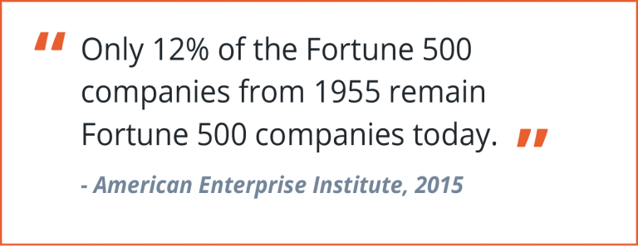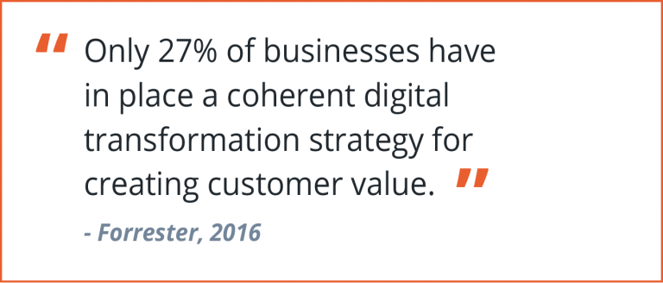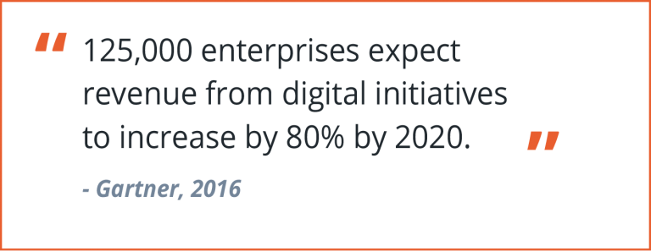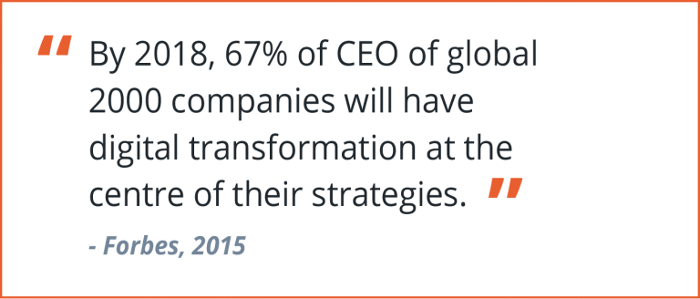

How different organization perceive digital transformation?

Testing the water framework

Digital transformation is a journey that is different for different organization depending on their destination. In most of the cases, approaches to digital transformation are based on the background of the the organization. Most of the organizations hire independent consultant for Digital Transformation and these consultant companies are leveraging well on this requirement. A recent report from IDC(International Data Corporation) says that globally organizations are going to spend around $ 1.3 Trillion on digital transformation efforts in the year 2018, which has increased a total of 18% from the total spend of the year 2017. IDC expects spending to almost double between now and 2021, when the total amount spent on digitalisation globally will surpass $2.1 trillion.

<https://www.idc.com/getdoc.jsp?containerId=prUS43381817>

//Establish the importance of Digital Transformation

// Element of Digital Transformation

In a survey of 460 execs by IT analyst Gartner, 62 percent said they had a management initiative or transformation program to make their business more digital. Just over half (54 percent) said that their digital business objective is transformational, while 46 percent said the objective of the initiative is optimization.

According to a recent survey conducted by Grant Thornton, more than two-thirds (69 percent) of CFOs and senior financial executives are planning to increase their investment in technologies that speed business change, and four in ten said they plan an increase of more than 10 percent in the next 12 months. Just under half said their companies' digital-transformation investments are meant to help them overtake their competition through differentiation.

Gartner Digital Transformation Report 2018

Before understanding the definition of digital transformation, let’s try to understand the promises of digital transformation

1. New Market Opportunities
2. Enhanced Customer Experience
3. Decreased Physical Infrastructure Dependency
4. Vastly Reduced timelines
5. Informed Decision making
6. Competitive Advantage
7. Operational Efficiency
8. New level of productivity

Digital transformation provides a great value from the perspective of customer and at the same time it also helps internal team to reduce the overall efforts by making the operations smoother.

It helps banks to reduce the overall cost and increase efficiency. It helps banks in informed decision making by providing data analysis. Digital transformation can also be leveraged by banks in creating new channels to onboard more customer.

<https://youtu.be/2q_lWLm5qtg?list=PL1-kPkZBw50H8ta2BnbQDq-3rl6IRywvH>

If you ask 10 CIO’s about the definition of digital transformation, they would give 10 different answers but one common theme : a long list of technology projects intending to foster sweeping business changes. As a matter of fact, Digital transformation has come to mean so many things that it’s almost meaningless. Banks have automated call centers, digitized sales channels, and catered to mobility — but does that really count as transformation?   
  
The answer is no. **Digital isn’t a channel — and transformation isn’t a project**. The fundamental purpose of digital transformation is not to digitize an existing state but to reimagine an entirely different business model that habitually places technology at its core.

Customers and small businesses can more easily pivot to a more digital state. But the same can’t be said for incumbent banks, whose legacy baggage acts more like shackles to drown them than a platform to stand on.

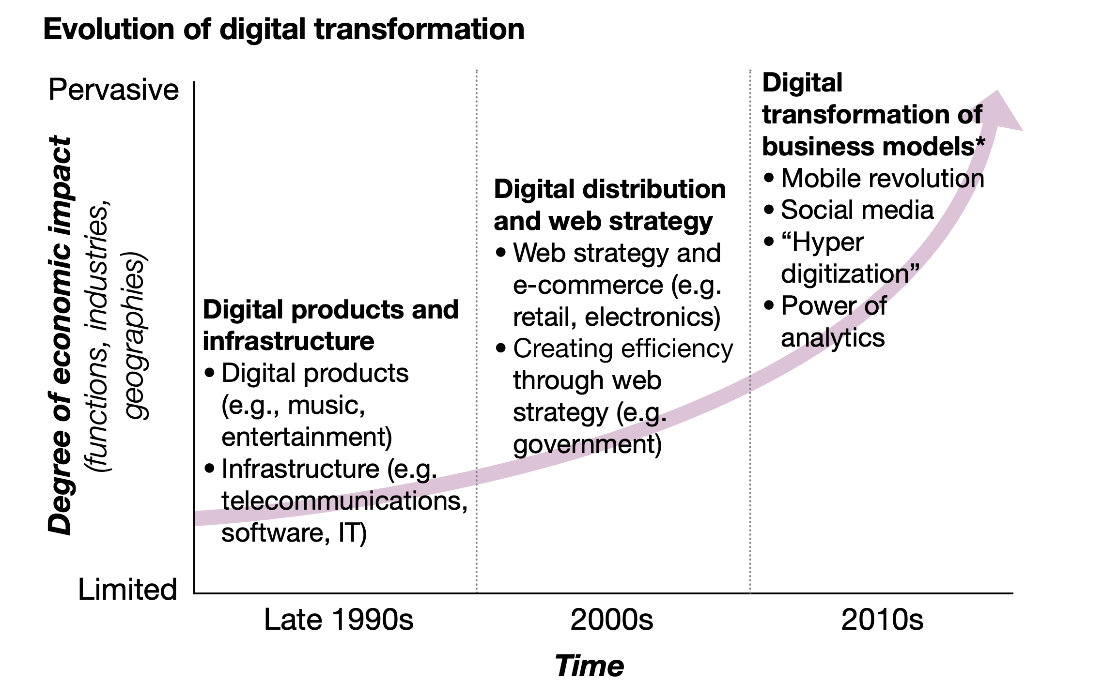

**The Confusion?**

**Digitization, Digitalization and Digital Transformation?**

As the hype around digital transformation continues to persist, the terms ‘digitization’ and ‘digitalization’ join the fray, increasing the level of hype while adding confusion. In reality Digitization, Digitalization and Digital Transformation have different meanings but people generally consider these terms synonymous.

Digitization: Digitization essentially refers to taking analog information and encoding it into zeroes and ones so that computers can store, process, and transmit such information. According to the Gartner glossary the digitization is the process of changing from analog to digital form” – a definition few would disagree with. The simplest example of digitization can be converting type or handwritten document into a digital/ document/pdf format.

**Digitalization:**

Unlike digitization, digitalization doesn’t have a single, clear definition. “‘Digitization’ and ‘digitalization’ are two conceptual terms that are closely associated and often used interchangeably in a broad range of literature,”

Brennen and Kreiss say that “We refer to digitalization as the way in which many domains of social life are restructured around digital communication and media infrastructures.”

Digitalization on social life – in other words, how people interact. As such interactions move away from analog tec  
hnologies (snail mail, telephone calls) to digital ones (email, chat, social media), both work and leisure domains become digitalized.

Gartner also weighs in on this term. “Digitalization is the use of digital technologies to change a business model and provide new revenue and value-producing opportunities,” according to Gartner’s glossary. “It is the process of moving to a digital business.”

it is evident that the way academia perceives digitalization is different from the way industry perceives. The basic difference is in the approach as academia thinks more in social interactions direction while corporate wants to develop newer business models.

**Digital Transformation: Beyond Digitalization**  
Digitalization, however, is quite distinct from digital transformation.  
  
An organization might undertake a series of digitalization projects, ranging from automating processes to retraining workers to use computers. Digital transformation, in contrast, is not something that enterprises can implement as projects.  
  
Instead, this broader term refers to the customer-driven strategic business transformation that requires cross-cutting organizational change as well as the implementation of digital technologies.  
  
Digital transformation initiatives will typically include several digitalization projects, but executives that believe that there is nothing more to digital transformation than digitalization are making a profound strategic mistake.

Seeing the current global scenario, the major understanding of digital transformation align with the incremental technological changes.

Seeing the great business opportunity, a lot of companies have proliferated recently as consultants in Digital Transformation. However role for some companies remain very limited into the overall transformation of the company. Majorly, there are two types of companies who are in Digital Transformation.

1. Business Consultants
2. Technology Consultants

In order to understand the overall picture, it was necessary to understand the modus operandi of all three types of firms. Broadly, organizations try to drive digital transformation from their areas of expertise. For example business consultants like BCG, PWC, KPMG and Bain generally put business model and redefining business model perspective into the transformation, while technology firms like Microsoft and Capgemini will try to accommodate technological transformation into digital transformation. Currently, there are very few design firms available in Digital Transformation. However, there is a lack of design thinking perspective in these transformation. There have been very companies who could actually understand the value of the combination of Design and Technology.

Mckinesy:

Mckinsey uses these 10 guiding principles to drive the digital transformation.

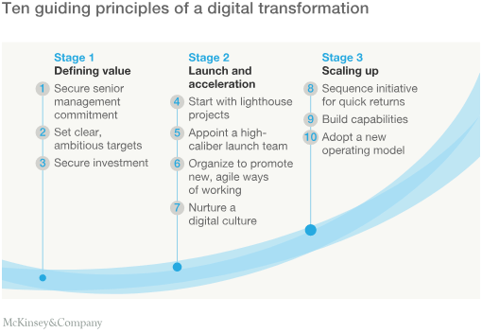

McKinsey digital transformation framework is focused on re-inventing the core and as per their definition the core of the company lies in these areas.

1. Value Proposition
2. People
3. Process
4. Technology

McKinsey’s 4D approach helps organizations to redefine the core.

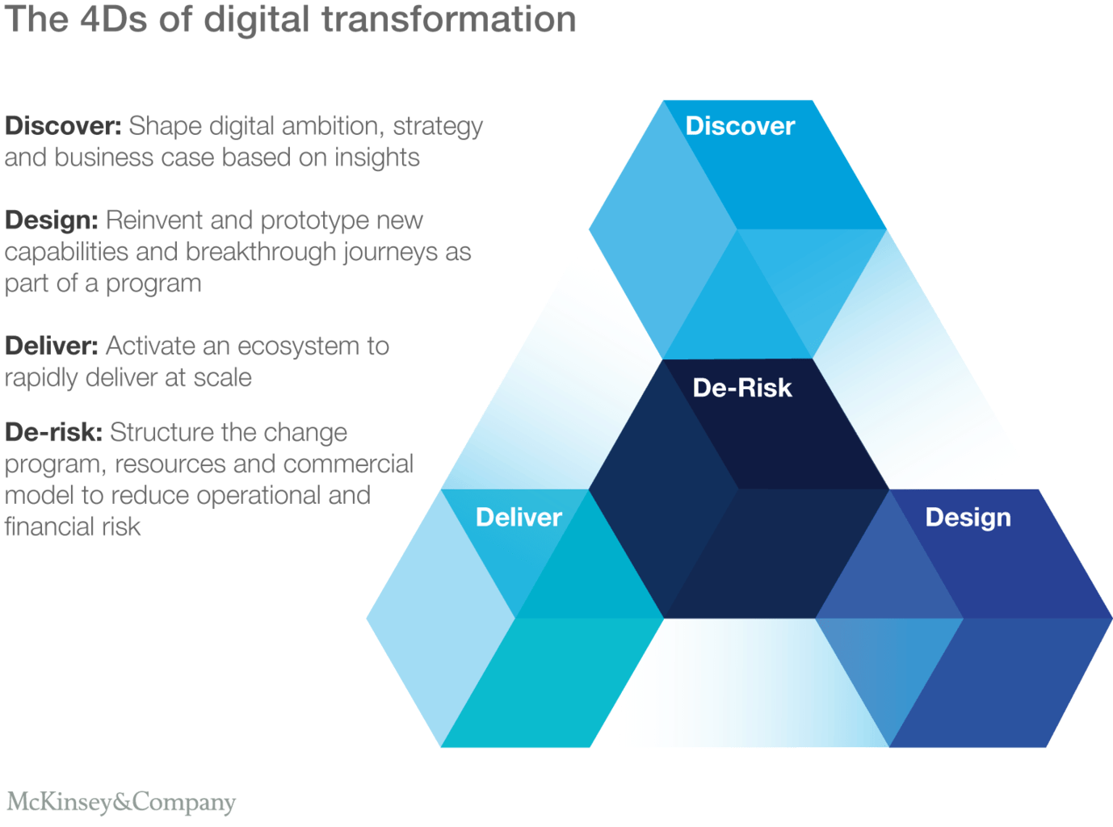

Discover what your digital ambition is (based on where the value is);  
Design programs that target profitable customer experience journeys;  
Deliver the change through an ecosystem of partners; and  
De-risk the process by thoughtfully sequencing steps

In the end McKinsey model talks about four key areas **Design and customer experience, Strategy and Innovation, Organizations and Operations, Technology**

Learning: McKinsey focuses heavily on their existing core capabilities. McKinsey’s model puts a new face to digital transformation but essentially remains the same. 4D model has a very unexplored dimension which takes care of risk analysis and rapid prototyping through a pre-established system.

Capgemini Model:

Capgemini is one of the companies, which started working on Digital Transformation at a very early stage. They did a research along with MIT and made their digital transformation framework public in year 2011.

Their digital transformation framework relies heavily on a top down approach for the leaders to first form the Digital Transformation vision and then transforming that vision to set the target and ambitions. This framework is not a linear framework and it is more comprehensive and detailed than McKinsey. This framework was specifically built for billion dollar companies, hence fits well in context of a large bank like Societe Generale.

<https://www.capgemini.com/wp-content/uploads/2017/07/Digital_Transformation__A_Road-Map_for_Billion-Dollar_Organizations.pdf>

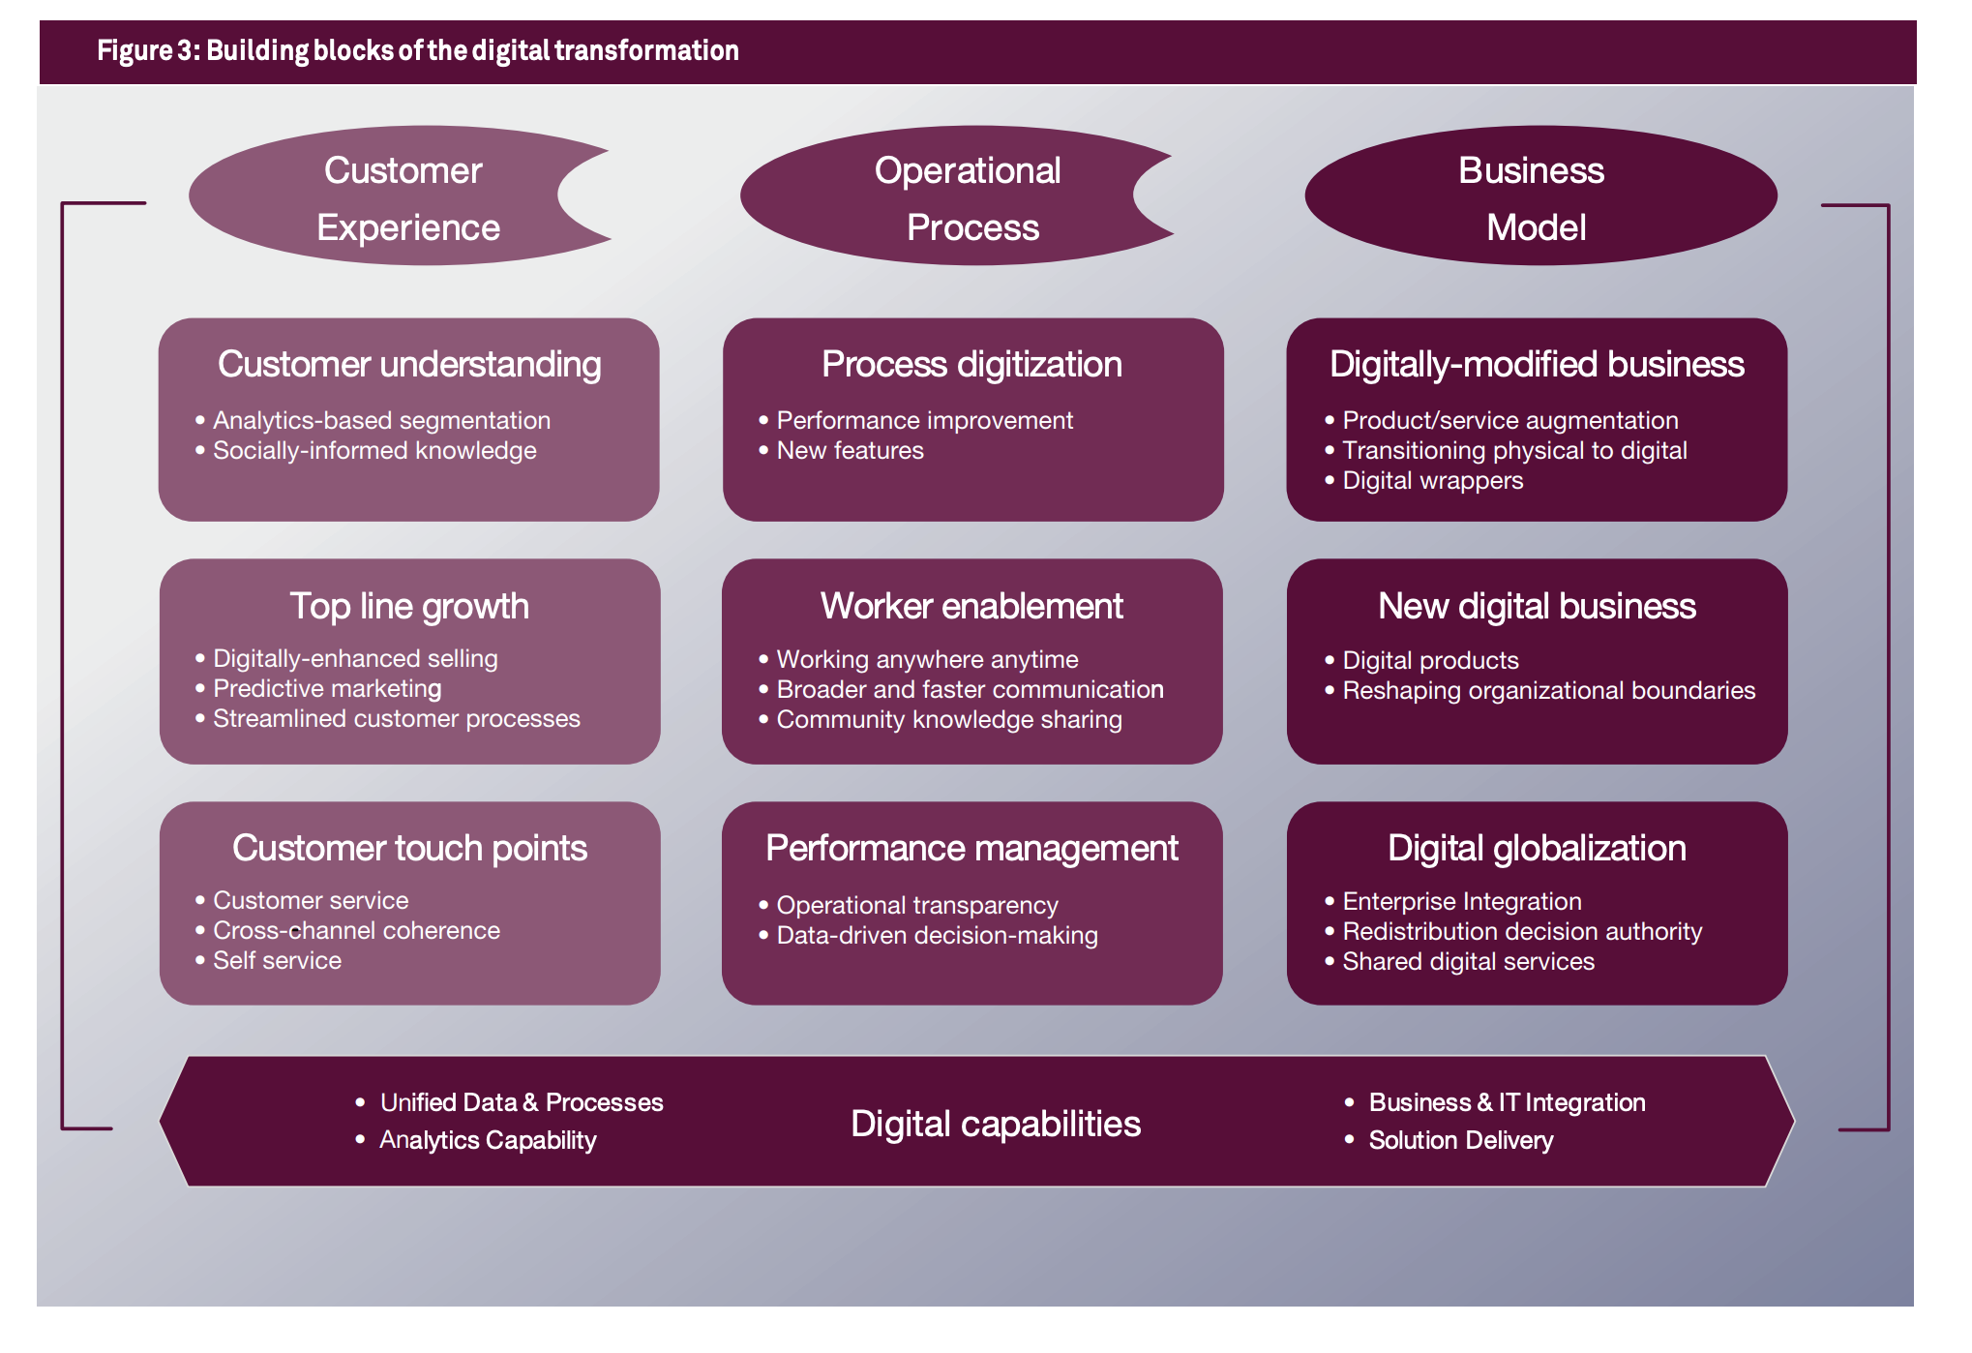

This framework also gives a classification of organizations at different stages of digital transformation. More about the classification will be discussed in Digital Transformation measurement section.

**Microsoft**:

Digital transformation is about reimagining how you bring together people, data and processes to create value for your customers and maintain a competitive advantage in a digital-first world.

Satya Nadela (CEO, Microsoft) specifically mentions that at Microsoft, we want to democratize this notion of digital transformation so that every business can truly harness the power of this digital era. We must also change how we go to market and better serve customers with core solution areas to enable this digital transformation.

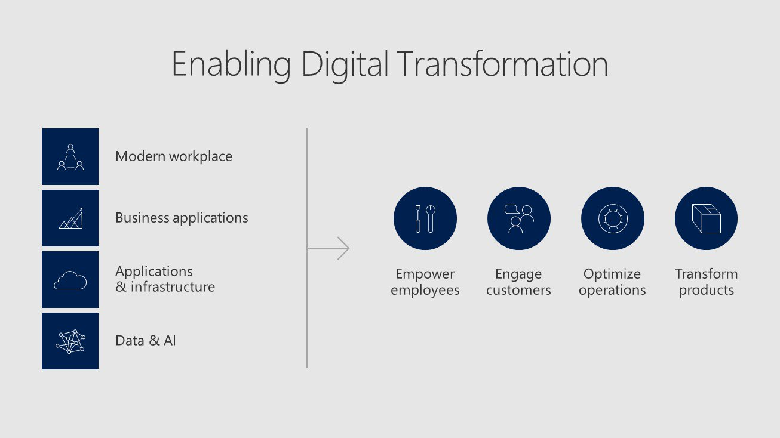

Though Microsoft provides a very detailed Digital transformation framework but it somewhat restricts the implementation through technology. Though the framework looks detailed but it tries to sell the Microsoft products like Office 365, Microsoft Azure (Cloud computing Platform). Below is a detailed map of Microsoft’s Digital Transformation steps breakdown.

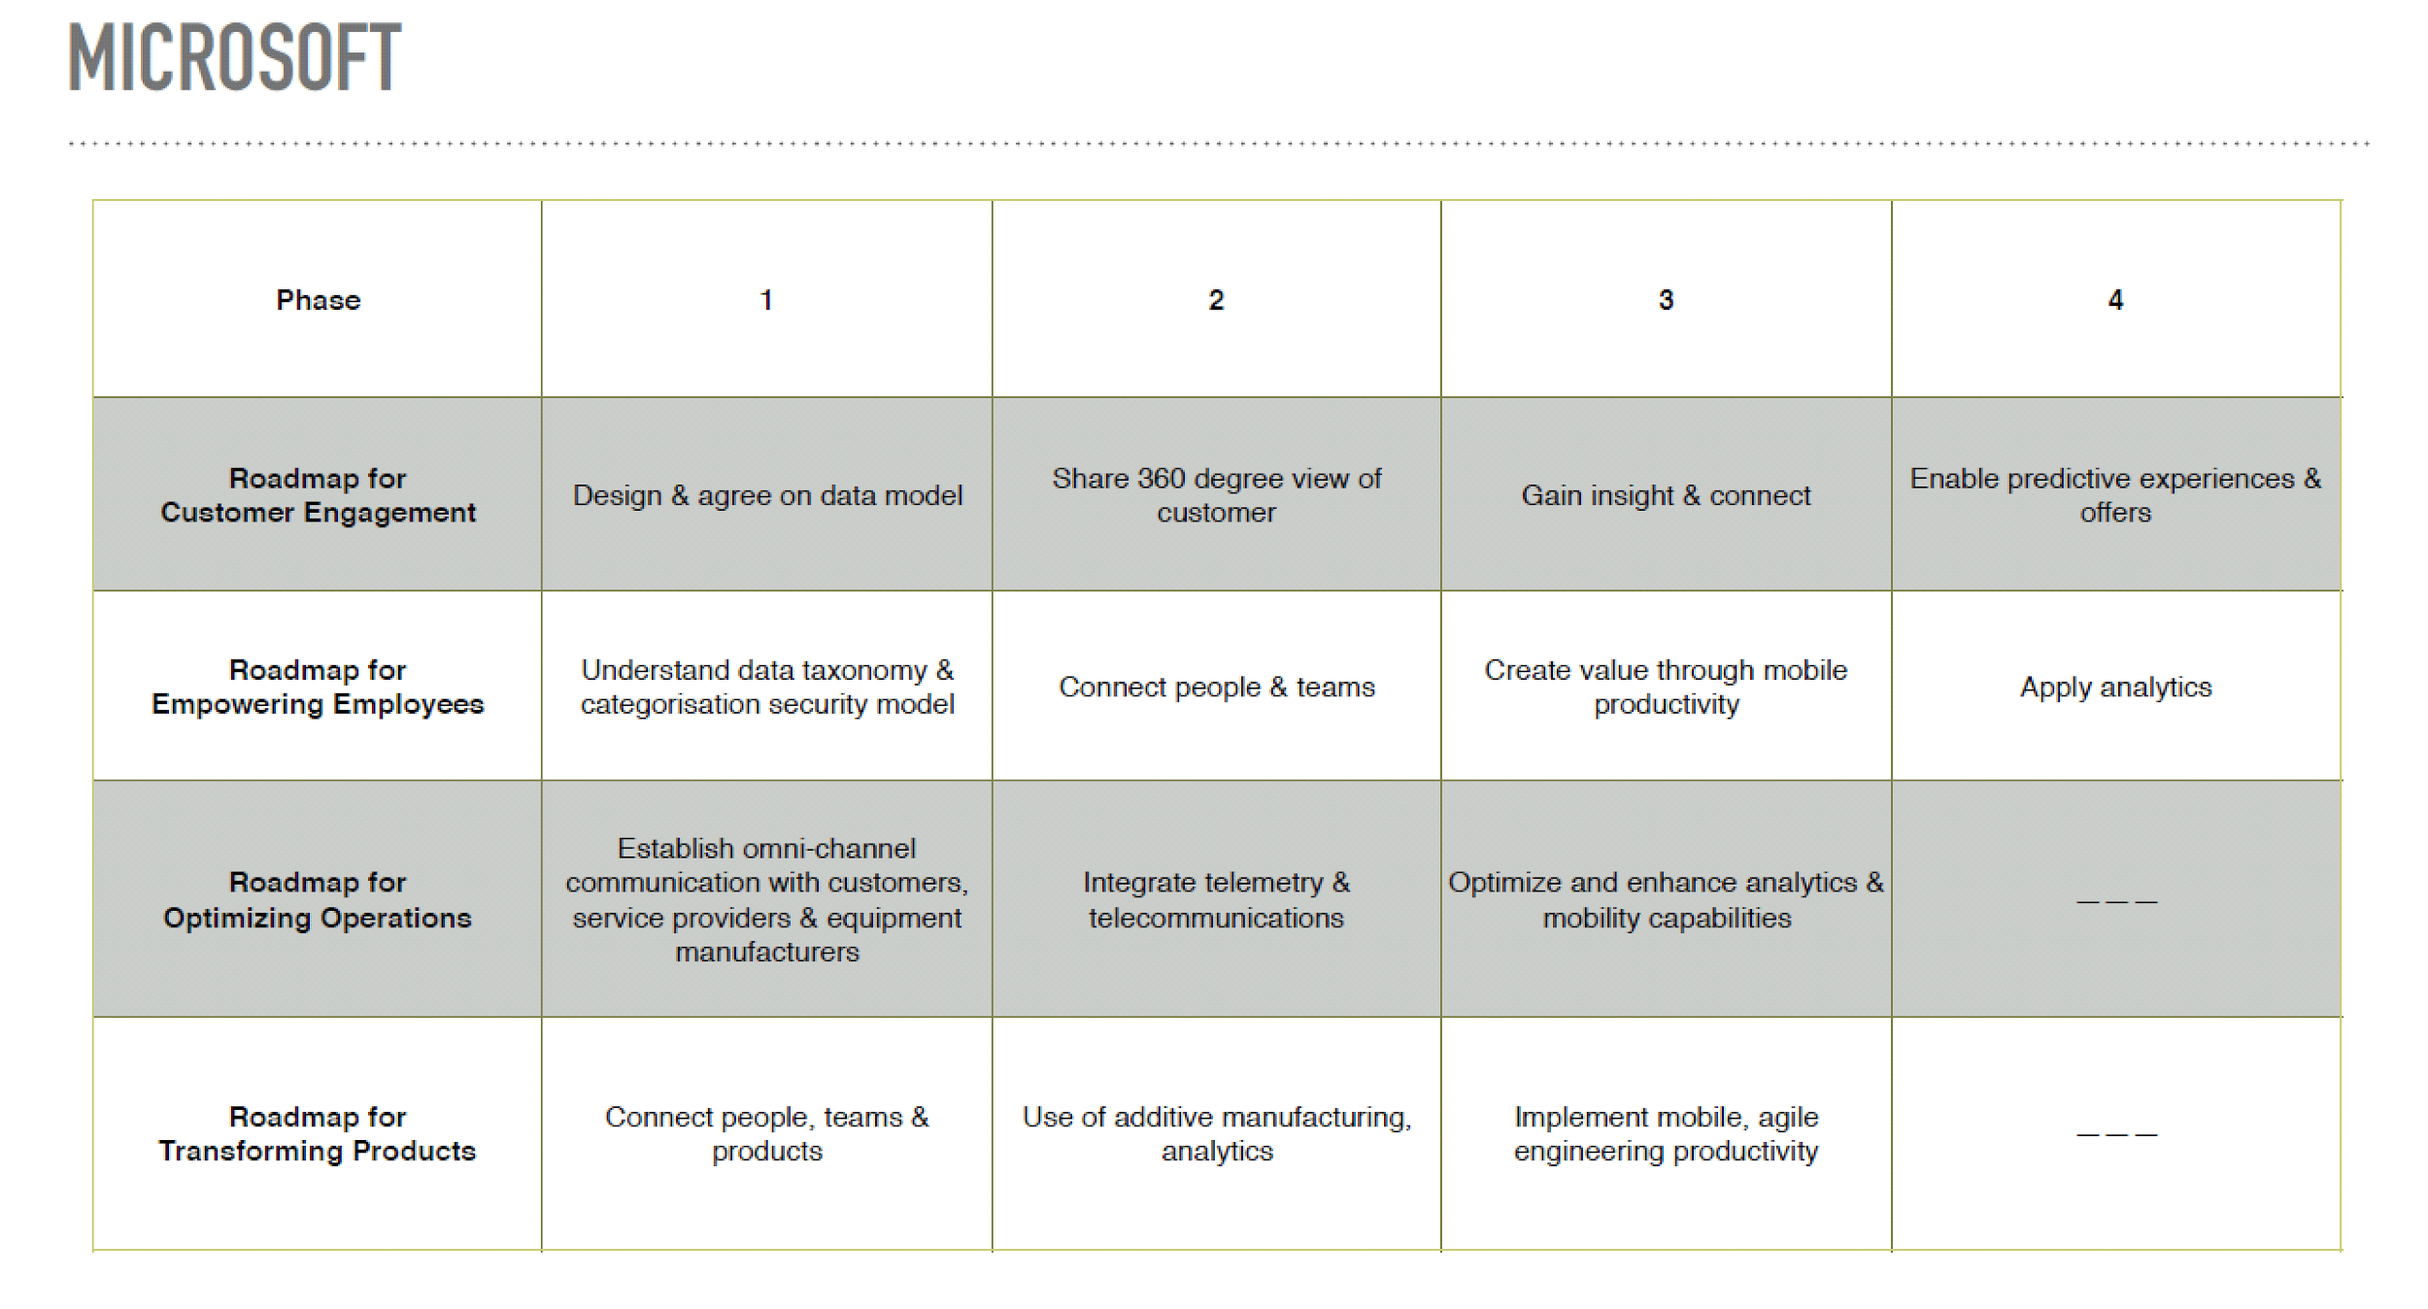

Put actual image instead of Screenshot of framework

IBM:

IBM’s digital transformation framework puts customer experience at the heart of all the activities by emphasizing on “Individual Centred Economy”. IBM has divided this into 7 steps, which they call 7 steps of Digital Reinvention.

Take it from Presentation

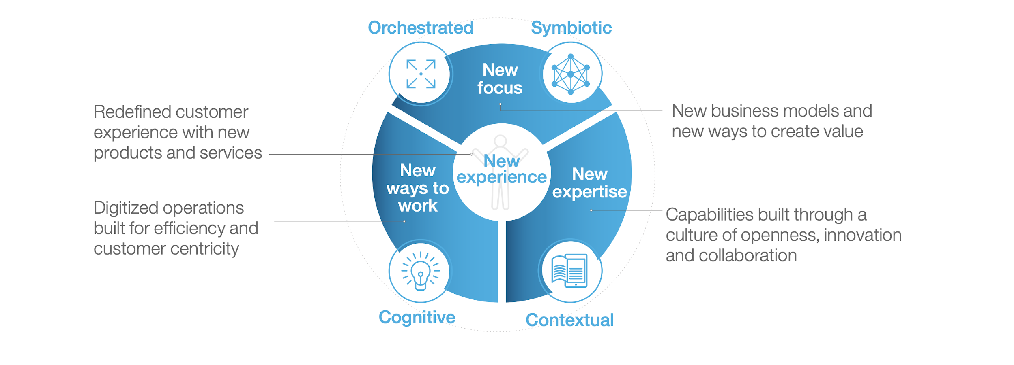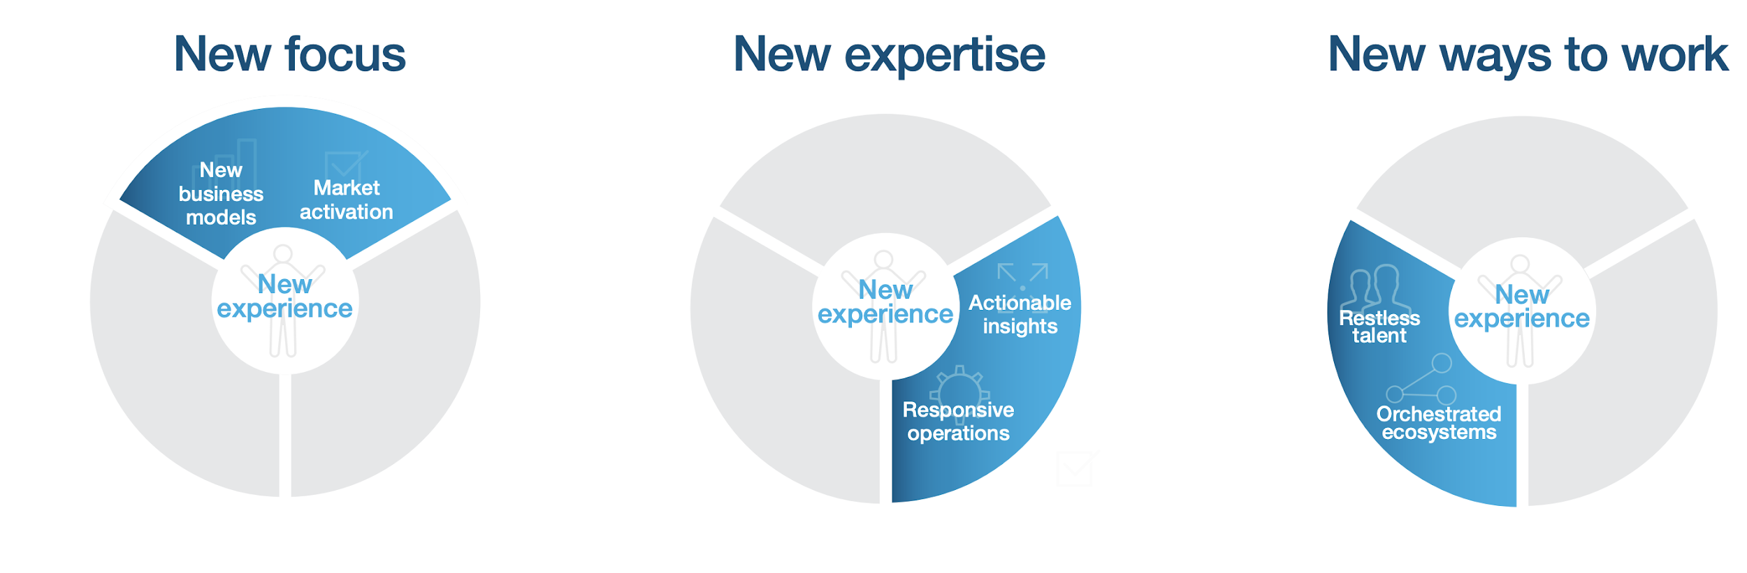

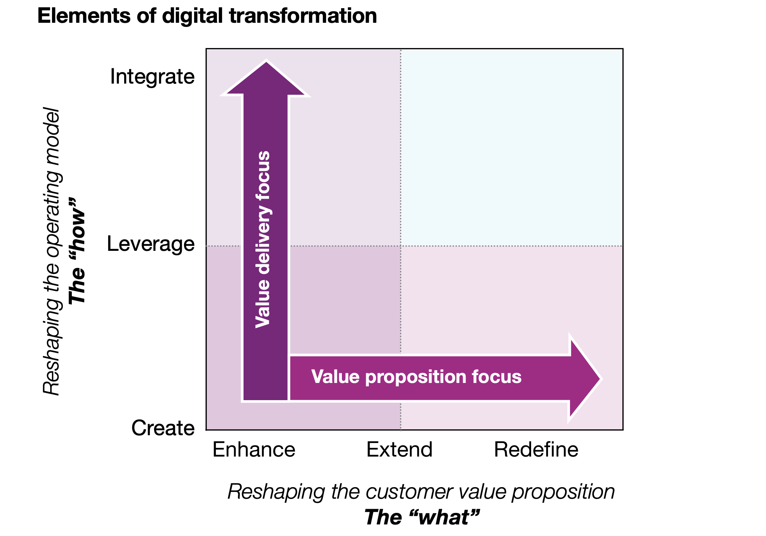

A comparative Study of Digital transformation Model’s

Create a table and take content from the presentation

BBVA, A case study in Digital Transformation:

BBVA is a customer-centric global financial services group founded in 1857. Its Purpose is to bring the age of opportunity to everyone. This Purpose reflects the Entity’s role as enabler, to offer its customers the best banking solutions, helping them make the best financial decisions and making a true difference in their lives. We live in the era of opportunities, where technology offers universal access to education and offers many more people than ever before the possibility of embarking on projects and chasing their dreams. BBVA helps people make their dreams come true. BBVA operates in more than 30 countries. The Group has a solid position in Spain, it is the largest financial institution in Mexico and has leading franchises in South America and the Sunbelt Region of the United States. It is also Turkish bank Garanti’s leading shareholder. Its diversified business is biased to high-growth markets and it relies on technology as a key sustainable competitive advantage. BBVA has a responsible banking model based on seeking out a return adjusted to ethic principles, legal compliance, best practices and the creation of long-term value for all its stakeholders.

The infographic below from their annual report 2017 shows a snapshot of existing situation.

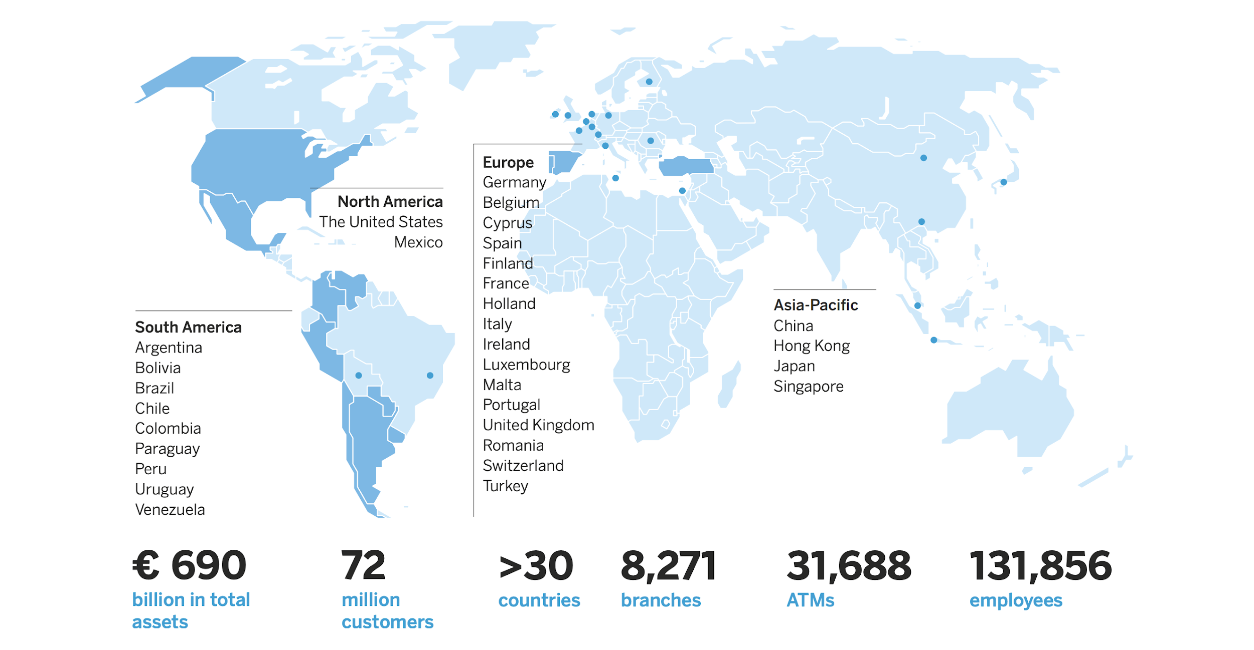

<https://www.capgemini.com/consulting-no/wp-content/uploads/sites/36/2017/08/bbva_pov_v6_03-03-16.pdf>

<https://shareholdersandinvestors.bbva.com/microsites/bbvain2017/downloads/bbva-in-2017-i.pdf>

Similarities in BBVA and Societe Generale

1. **Legacy Banks**: Both BBVA and Societe Generale have a long history of almost 150 years. Infact, BBVA started in the year 1857 while Societe Generale started in the year 1864. Both the banks have a long history and they almost have a very traditional set of problems because of same background.
2. **Market** : BBVA predominantly operates in more than 30 countries in South America, North America, European region and Asia Pacific. Societe Generale serves 31 million customers and is present in almost 60 countries. Their presence in similar types of regions with similar set of customers makes it more comparable. Though BBVA has more than 72 million customer but they have lesser number of total assets around 690 billion euros which is lesser than Societe Generale’s 1.27 trillion euros.
3. Similar Challenges: Since both the banks are legacy banks hence they have broadly similar types of challenges. BBVA and Societe Generale have a similar type of offerings and it requires various processes to successfully deliver the value to the customer.

In hindsight, BBVA successfully realised the digital vision they set and have received several accolades from the banking industry but it was a difficult challenge. Generally, it is said that overnight success is a myth and it seems very valid in case of BBVA’s journey of Digital transformation. Today BBVA claimed to have reached the digital tipping point(50% customer) in Spain. It took almost 10 years to completely transform the bank from a traditional banking model to a new age customer centric banking model. The mission BBVA started in 2007, took almost 10 years to reach at a stage where BBVA can rely upon their banking system.

BBVA’s started their digital transformation journey at a very early stage

1. when economy was approaching towards all time low state
2. Fintech companies were emerging
3. It was becoming difficult to be profitable in overburdensome regulations
4. It was difficult to restore consumer confidence
5. It was difficult to maintain employee’s motivation and skills

BBVA took these new structural trends seriously and setup a clear digital vision which states that “**Our goal is to turn BBVA into a totally digital company, including all our products and services, and with our more than 100,000 employees working digitally**”. Meantime, accenture also published a report which came as a shocker to most of the banks. The report says that **People have started trusting tech companies more than banks.** As per the report around 29% of people said that they would bank with Apple if they could. Over 70% of millennials say they would be happy to pay for banking products and services provided by non-banking companies (GAFA)—for example, telecommunications operators, technology and internet providers, online retailers. These percentages exceed 50% even among earlier generations—aged up to 55 years. It was very clear for banks to realign the strategy with the changing trends. Hence new needs were impacting banks on two level

1. Direct threat from new customers from companies like Google, Amazon
2. Emergence of decentralized money exchange platforms

In march 2015, CEO Francisco González pointed out the dramatic impact that technology is having on the transformation of the financial sector and expressed a all new vision for the company. He said that "**BBVA will be a software company in the future**”.

In order to keep the bank at an industrial pace of growth, BBVA mapped out a strategy framework for its transformation.

//Put Digital Transformation Framework

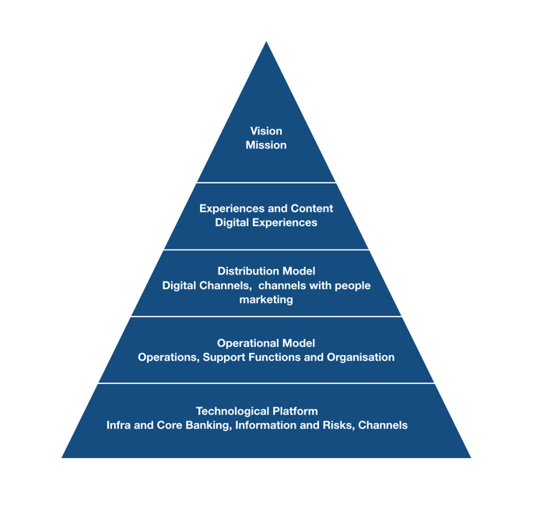

1. Building a strong infrastructure foundation
2. Focusing relentlessly on the customer experience
3. Embracing digital disruption
4. Knowledge driven banking

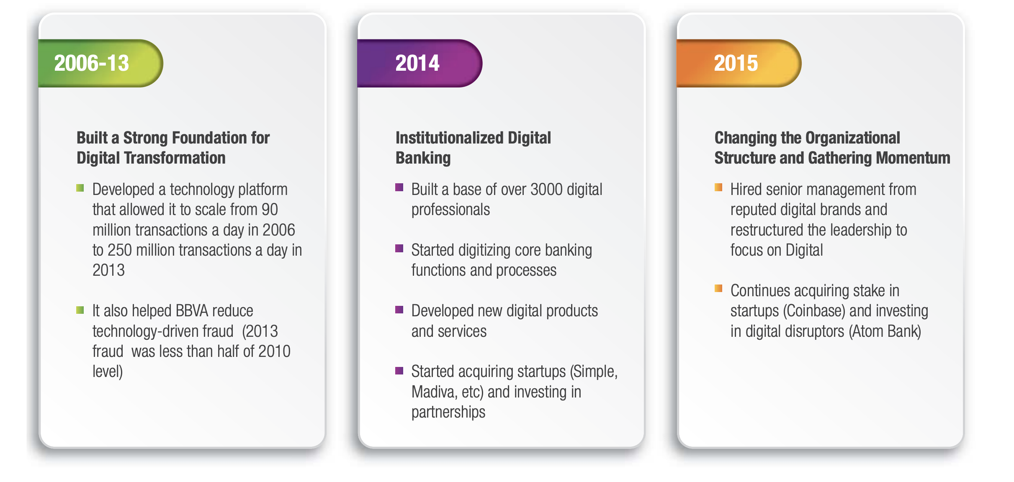

After setting the vision and strategy BBVA started the execution of Digital Transformation. Francisco mentions in an interview that “**To build the banking technological platform from scratch is like changing the pieces of an engine of a lorry as it zooms down the highway.”**

But with the support of a robust framework and commitment from employees, BBVA successfully implemented the laid out strategy. BBVA doubled its investment in building technology capabilities from €1.2 billion in 2006 to €2.4 billion in 2013.

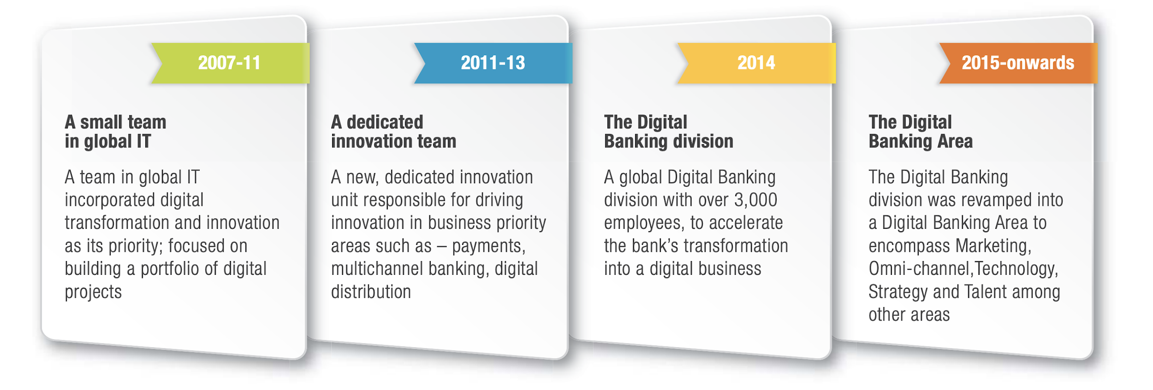

Derek White, Global Head of Client Solutions, explains that one of the driving factors for the bank’s transformation was to help its customers interact with the bank. To achieve this, it was key to identify the top fifty reasons why customers would walk into a branch.  
  
Once armed with this data, BBVA began working on making these needs DIY-able, ensuring that customers could instead do most of these things on their mobile devices. Customers thus save time and are able to do their banking with complete autonomy, whenever and wherever they want. Additionally, the bank developed a detailed catalog of the banking services and transactions, ranging from checking their account balance to applying for a mortgage. The catalog included a total of 973 services. According to White, this catalog served as the basis for strengthening the bank’s DIY offering and also a blueprint for determining how you build services into digital platforms, and how you share them across The Group. Now, 94 percent of the bank’s retail products and services are available as do-it-yourself transactions. The BBVA App launched earlier this year in Mexico is included in this offering and represents the first truly global mobile-banking application.

White recalls that thanks to the adoption of the Single Development Agenda, the bank was able to improve its product delivery by four times. Additionally,with the use of the global development platform, products are developed once, then they can be reused multiple times across the bank’s different operating countries. T**his process is called the “3,6,9 process” – three days to build a team, six weeks to develop a prototype, and 9 months to deliver the product or service into the hands of the customer.**BBVA’s Head of Client Solutions goes on to explain how the mechanical production process across the bank also changed. The process consists of nine steps that ensure homogeneity in developing products and services and uses a wide-range of techniques including behavioral economics, design and user experience, and even back-end processes that include data management and API development.

**Design at the heart of BBVA:**

BBVA is one of among the rare banks who places design at the heart of the organization. BBVA formed a team of 150+ designers that focused on driving organizational change using design. BBVA penetrates design inside organization by imparting knowledge to everyone/team by launching design Ambassadors(1000) program. BBVA also started spreading design special initiatives like Design Wednesdays which played a major role in taking design to leverage at a strategic level. **e**very project starts with active collaboration of Design, Engineering and Business.

**BBVA uses “The 3-6-9 formula” to**  create customer experiences at pace (3 days to identify the team that will work on the project , 6 weeks to deliver an initial prototype of the project, up to 9 months to convert the project into a solution in the hands of our customers). This methodology involves active collaboration of Design, Engineering and Business at the beginning of all projects.

BBVA design team also built a product-Compass for employee to demonstrate products to customers(Never ask your user same information twice).

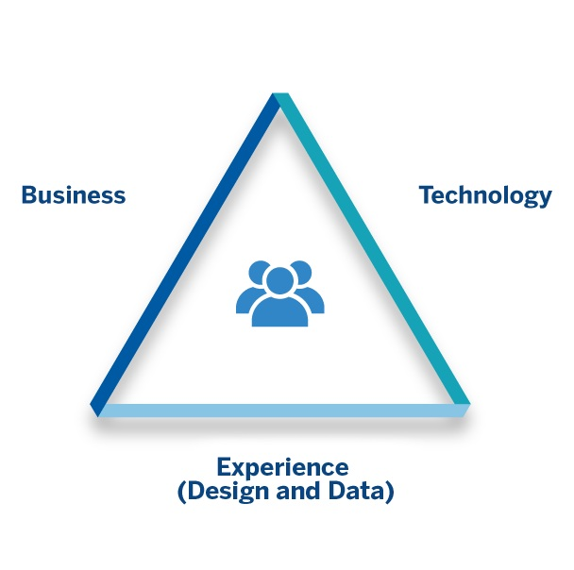

To counter lot of critics for extensively using design and building center of excellence , In one of the interview, Derek White says that “**Honestly, the mindset at BBVA is different. We realize that if you focus on the client, and if you design for their needs in a beautiful way, then the costs of doing that take care of themselves”**

Design team introduced the concept of Digital experience pods inside the retail banks, where bank officers can give you a walkthrough of all products and services.

Handling Fintech Wave:

BBVA has also increasingly engaged with the digital startup community, with the bank acquiring startups such as Simple and Madiva to beef up its digital banking services. In 2013, BBVA also invested $100 million to establish BBVA Ventures, a venture capital fund that invests in promising startups in the FinTech sector . **In 2015, BBVA announced plans to invest £45 million for a 29.5% stake in Atom Bank, UK’s first mobile-only bank .** In February 2016, BBVA shut down BBVA Ventures, took its $100 Mn portfolio and added an additional $150 Mn to create a fintech-focused venture capital firm called Propel Venture Partners. By spinning out the fund, the bank hoped to reach a wider range of companies while working around the challenges of managing ventures in existing large organizations. The strategy behind these moves is to tap into the market of digital customers and to fight disruption by putting customer first.

Today:

Today BBVA is standing at the peak in many countries and almost on second or third in many countries. Their total volume of transaction has increased from 90 million to 1.2 Billion. BBVA serves more than 40% customers on mobile. BBVA has more than 50% customer digital. BBVA is being ranked number one in NPS rating in many countries like Spain, Turkey, Mexico, Argentina, Venezuela, Columbia etc.

BBVA’s journey of transformation has been an inspirational journey. They identified the trends and weak signals at the right time and laid out a new strategy which took care of right requirement at the right time. BBVA’s inward and outward looking digital transformation not only changed the outlook of the bank but the internal functioning of the bank also.

Measurement of Digital Transformation:

There are different methodologies of measuring digital transformation. Among these methods, there are two specific methods developed by McKinsey and MIT/ Capgemini can be useful for the purpose of the study.

https://www.mckinsey.com/featured-insights/digital-disruption/raise-your-digital-quotient

1. Digital Quotient by McKinsey : Digital Quotient® (DQ) measures an organization’s performance across four key dimensions of digital maturity. Executives use the results to compare their performance against hundreds of organizations and digital leaders, identify their digital strengths and weaknesses across business units, and prioritize the initiatives of greatest potential impact.
2. Strategy: Are we aligned around a vision? Are goals in place to meet short- and long-term digital-business aspirations?
3. Culture : Are we fostering the mindsets and behaviors critical to capturing digital opportunities?
4. Organization : Do we have the right structures, processes, and talent in place to execute our digital strategy?
5. Capabilities : Do we have the systems, tools, digital skills, and technology to achieve our digital goals?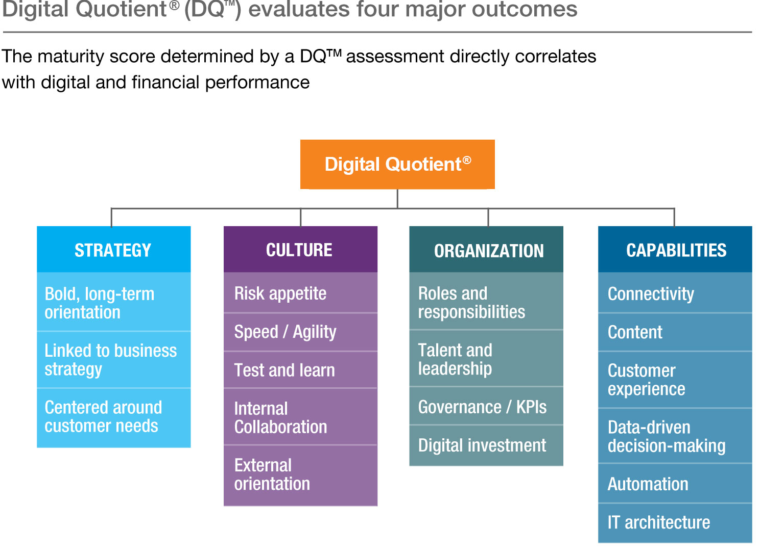

Digital Maturity Matrix: It is a classic 2*2 matrix having digital intensity on vertical axis and transformation management intensity at horizontal axis. It divides digital companies in four categories which are going through digital transformation. Firms in the lower left are Digital Beginners. They are doing very little with advanced digital capabilities, although they have more traditional digital capabilities such as ERP, internet or e-mail. Companies may be in this quadrant by choice. For example, executives in a specialty chemicals firm believe that their B2B customers will not be interested in social media or mobile technologies, and that their engineering employees are very effective with traditional collaboration tools. However, many companies are in this quadrant by accident. They are either unaware of the possibilities of new digital technologies or are starting some investments without effective transformation management in place. Firms at the top left are Digital Fashionistas.

Digital fashionistas are motivated to bring on digitally powered change, but their digital transformation strategy is not founded on real knowledge of how to proceed. As a result, fashionistas may look good, but rarely have much substance – in terms of business value – behind the sizzle. We see many fashionistas in B2C businesses, where executives (especially the marketing units) believe they must move fast to keep up with the fast-moving world of consumer electronics, but do not necessarily have a clear vision for how the elements will collectively create value. Some firms are in this quadrant at the enterprise level even though digital efforts in silos may be in other quadrants. This is the case with a hospitality firm, in which marketing and customer service are both relatively mature digitally, but the two are not yet well coordinated.

Firms at the bottom right are Digital Conservatives. These represent the wise old men and women of the digital world. They understand the need for a strong unifying vision and for governance and internal engagement activities to ensure prudent investment management. However, they are typically skeptical of the value of new trends, sometimes to their detriment. Digital conservatives understand where the company should be going and how to master digital challenges, but they can’t always build organizational momentum to carry out an ambitious program. As a result, though aiming to spend wisely, their careful approach may cause them to miss valuable opportunities that their more stylish competitors will pounce on.

Firms at the top right are Digirati. These firms truly understand how to drive value from digital transformation. They combine a strong shared vision for transformation, careful governance and engagement, and sufficient investment in new opportunities. Through managing the “how” carefully, they develop a digital culture that can envision further changes and implement them wisely. Through managing the “what” sufficiently, they continuously advance the competitive advantage they draw from implementing digital transformation.

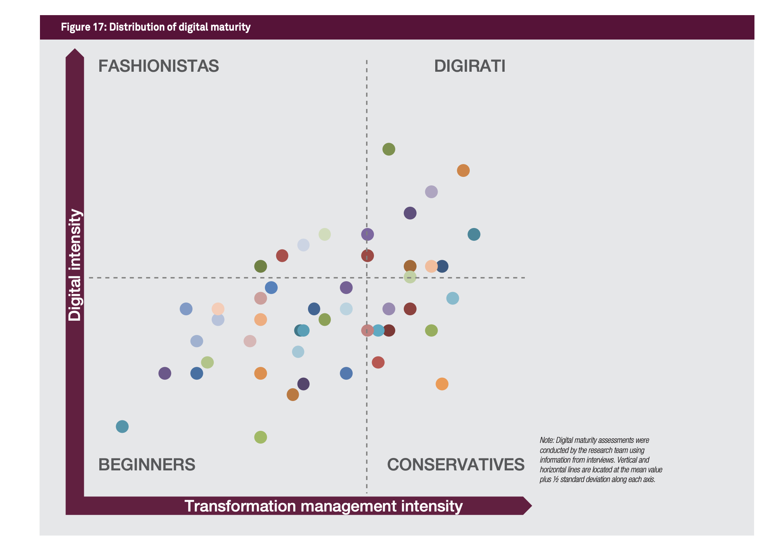

**Elements of Digital Transformation:**

Though digital maturity matrix of MIT/Capgemini and Digital Quotient model of McKinsey highlight the few aspects of Digital transformation but the core elements of digital transformation vary as the context changes. It is important to understand the different aspects of digital transformation from different frameworks. Author explored around 6 frameworks and out of these 6 frameworks, two frameworks were finalized based on the holistic nature and reliability of the source. It was decided to include an industry perspective and one book perspective. A framework can be devised only after understanding the core aspects of any subject.

**Books Perspective:**

Digital Transformation Playbook:

David L Rogers writes how digital forces are reshaping five key domains of strategy: customers, competition, data, innovation, and value. These five domains describe the landscape of digital transformation for business today. Across these five domains, digital technologies are redefining many of the underlying principles of strategy and changing the rules by which companies must operate in order to succeed. Many old constraints have been lifted, and new possibilities are now available. Companies that were established before the Internet need to realize that many of their fundamental assumptions must now be updated.

Customer : The first domain of digital transformation is customers. In traditional theory, customers were seen as aggregate actors to be marketed to and persuaded to buy. The prevailing model of mass markets focused on achieving efficiencies of scale through mass production. In the digital age, we are moving to a world best described not by mass markets but by customer networks. In this paradigm, customers are dynamically connected and interacting in ways that are changing their relationships to business and to each other. Customers today are constantly connecting with and influencing each other and shaping business reputations and brands. Their use of digital tools is changing how they discover, evaluate, purchase, and use products and how they share, interact, and stay connected with brands.

Competition: The second domain of digital transformation is competition: how businesses compete and cooperate with other firms. Traditionally, competition and cooperation were seen as binary opposites: businesses used to compete with rival businesses that looked very much like themselves, and they cooperated with supply chain partners who distributed their goods or provided needed inputs for their production.

**Data** : The next domain of digital transformation is data: how businesses produce, manage, and utilize information. Traditionally, data was produced through a variety of planned measurements that were conducted within a business’s own processes—manufacturing, operations, sales, marketing. The resulting data was used mainly for evaluating, forecasting, and decision making.

By contrast, today we are faced with a data deluge. Most data available to businesses is not generated through any systematic planning like a market survey; instead, it is being generated in unprecedented quantities from every conversation, interaction, or process inside or outside these businesses. With social media, mobile devices, and sensors on every object in a company’s supply chain, every business now has access to a river of unstructured data that is generated without planning and that can increasingly be utilized with new analytical tools.

These “big data” tools allow firms to make new kinds of predictions, uncover unexpected patterns in business activity, and unlock new sources of value. Rather than being confined to the province of specific business intelligence units, data is becoming the lifeblood of every department and a strategic asset to be developed and deployed over time. Data is a vital part of how every business operates, differentiates itself in the market, and generates new value.

**Innovation**: The fourth domain of digital transformation is innovation: the process by which new ideas are developed, tested, and brought to the market by businesses. Traditionally, innovation was managed with a singular focus on the finished product. Because market testing was difficult and costly, most decisions on new innovations were based on the analysis and intuition of managers. The cost of failure was high, so avoiding failure was paramount. Today’s start-ups have shown us that digital technologies can enable a very different approach to innovation, one based on continuous learning through rapid experimentation. As digital technologies make it easier and faster than ever to test ideas, we can gain market feedback from the very beginning of our innovation process, all the way through to launch, and even afterward.

**Value**: The final domain of digital transformation is the value a business delivers to its customers—its value proposition. Traditionally, a firm’s value proposition was seen as fairly constant. Products may be updated, marketing campaigns refreshed, or operations improved, but the basic value a business offered to its customers was assumed to be constant and defined by its industry (e.g., car companies offer transportation, safety, comfort, and status, in varying degrees). A successful business was one that had a clear value proposition, found a point of market differentiation (e.g., price or branding), and focused on executing and delivering the best version of the same value proposition to its customers year after year.

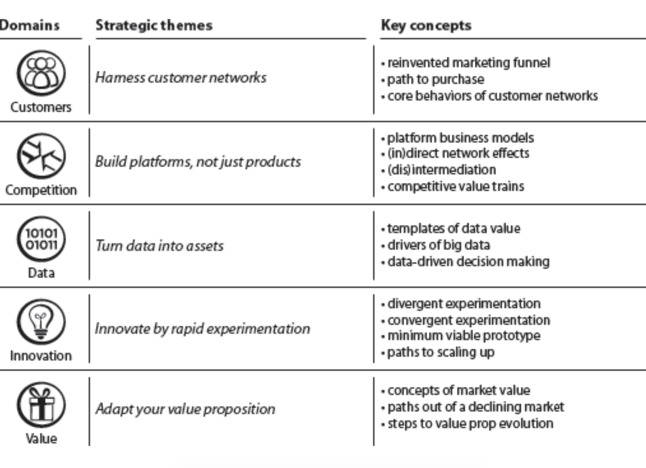

**The Nine element of Digital Transformation by HBR:**

The Harvard Business review describes that executives are focusing on digitally transforming three key areas: customer experience, operational processes, and business models. And each of these three pillars has three elements that are changing. These nine elements form a set of building blocks for digital transformation.

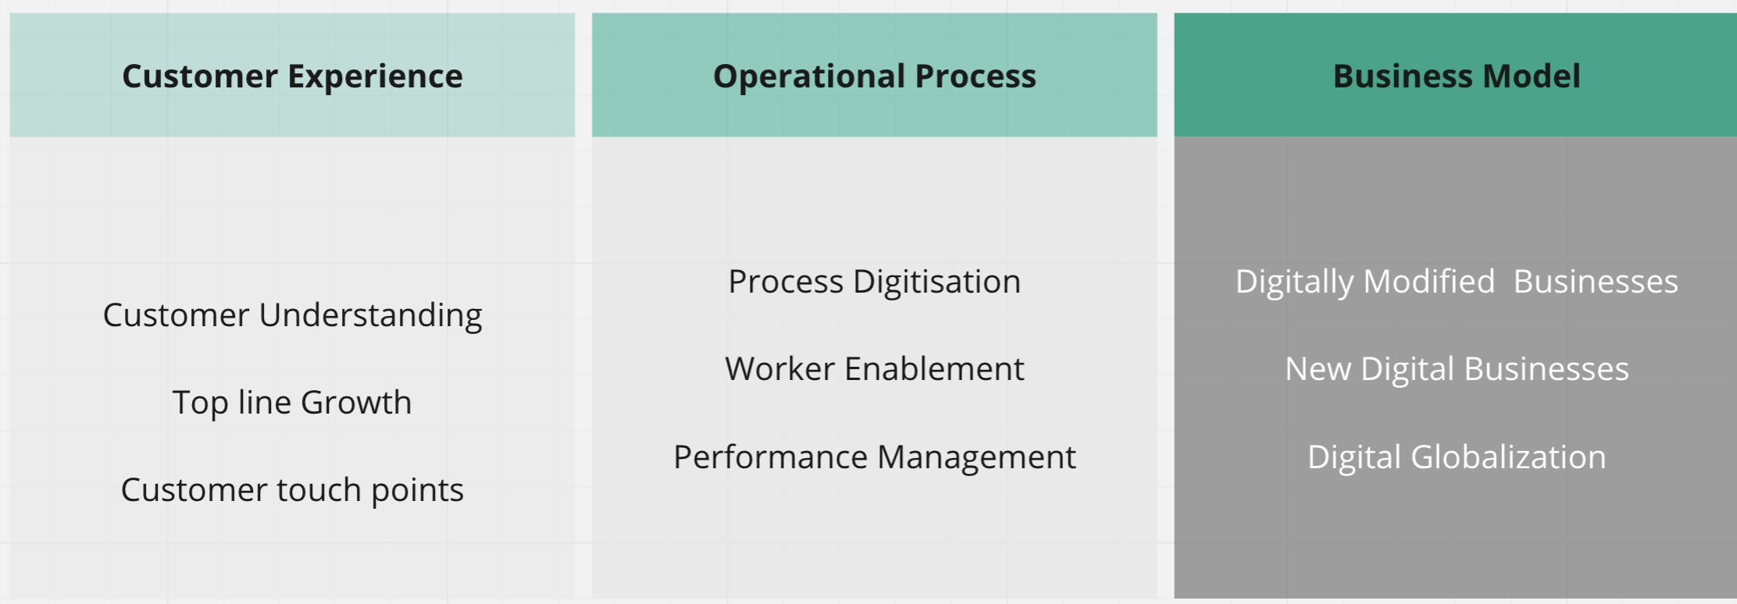

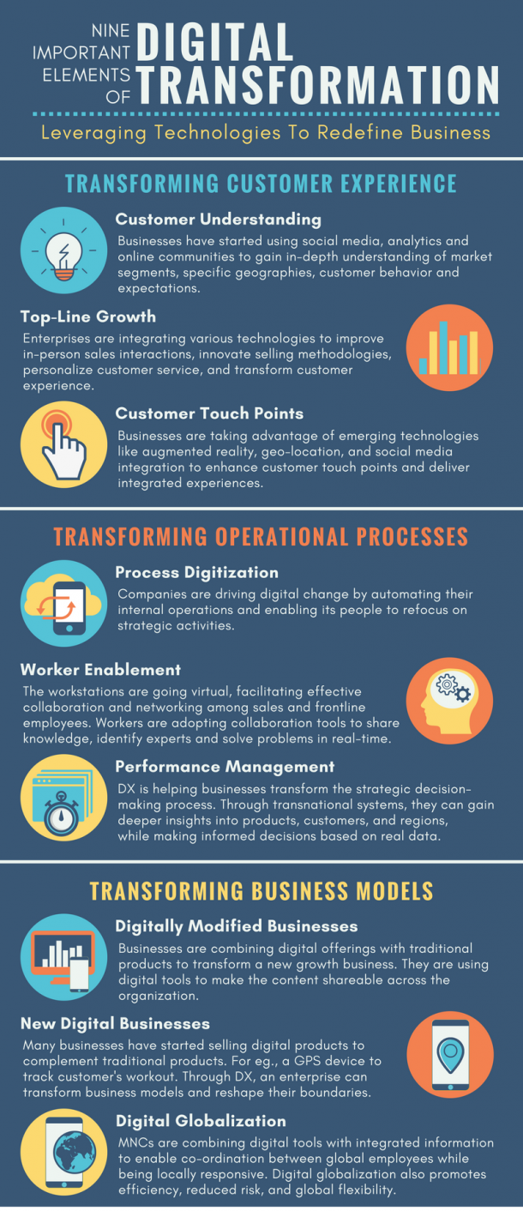

Though most of the models have kept technology as the main driver of the transformation. But very few of the organizations actually do not keep technology as the core of the transformation. Even Roger’s model of Digital transformation lacks certain perspectives like business, culture and leadership. Harvard’s model however considers important dimension of transformation, though puts limited focus on setting a strong digital vision. The capgemini model (Discussed in frameworks) however gives a closer picture though seems outdated and irrelevant today as it was proposed around 2011.

Digital Transformation is ultimately about change and change management to align organization with the evolving technology. As a metaphor, these elements can be considered knobs of an organization which can be used to steer organization to realign it for the modern digital age requirements.

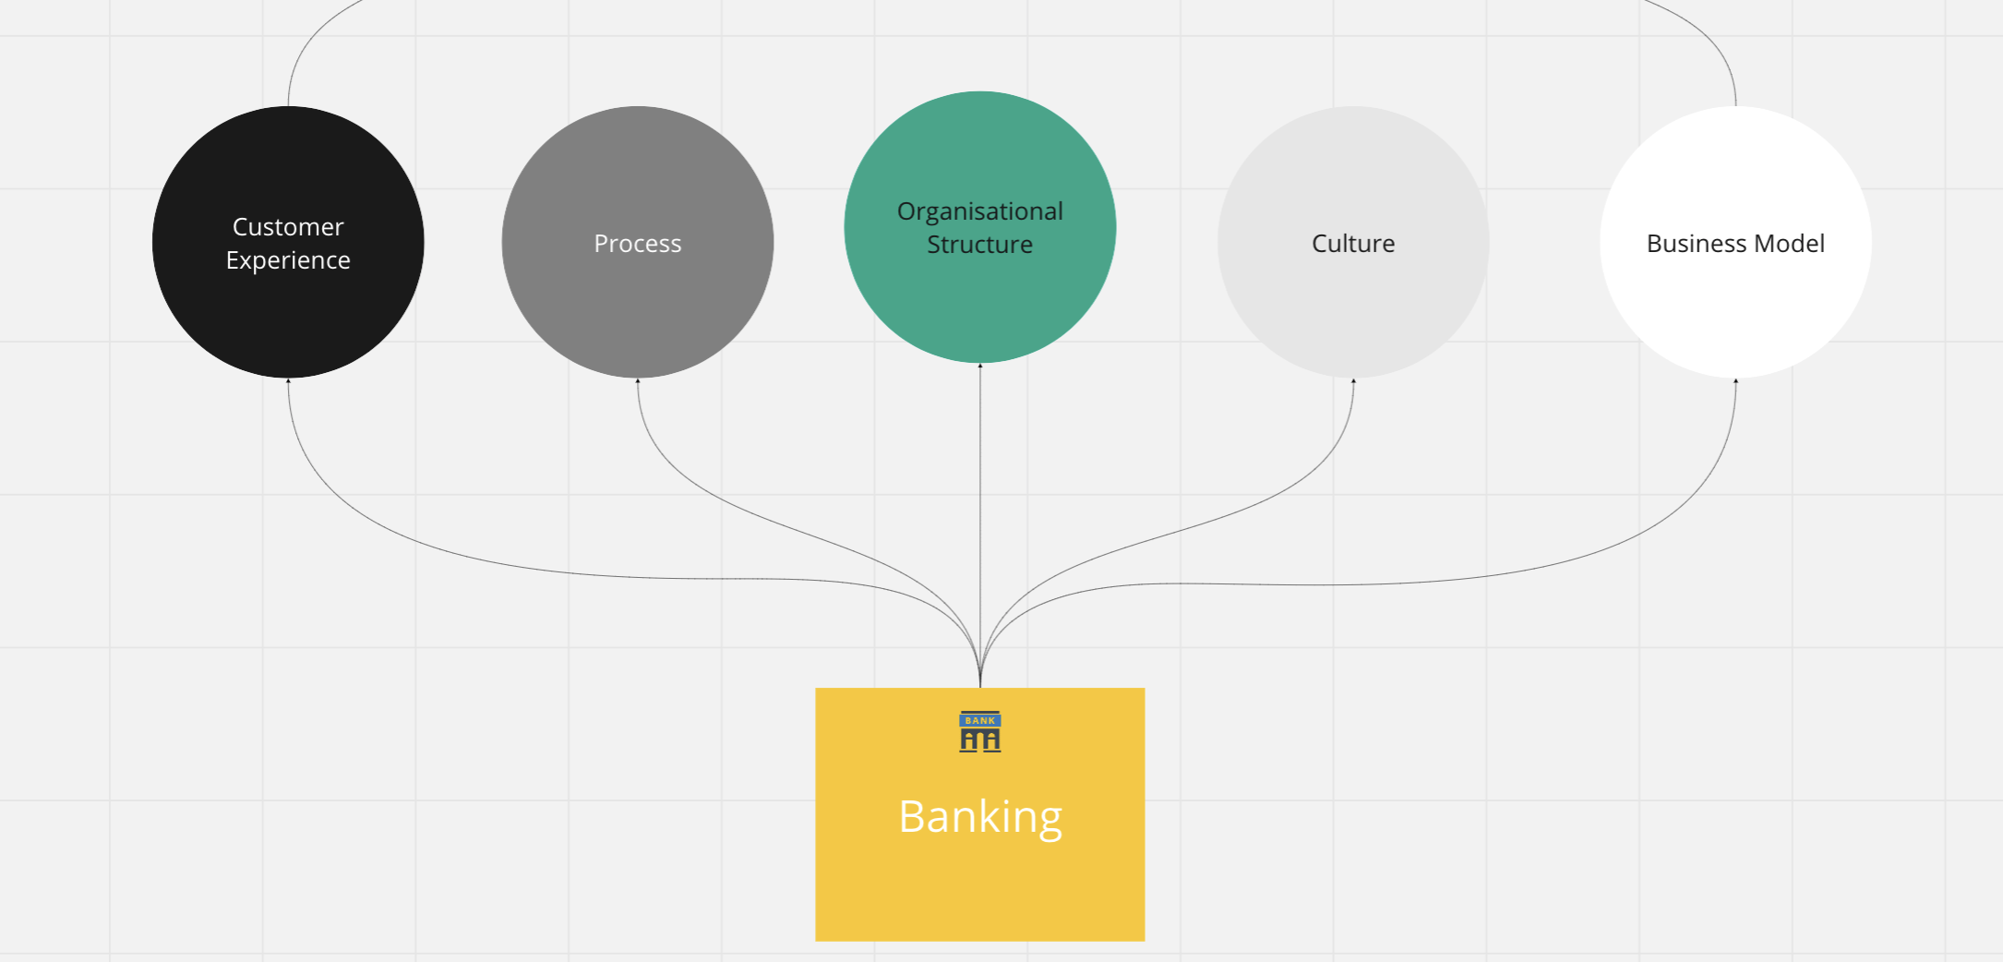

These digital transformation models are general and are source of sales for organizations to secure the business assignments. Defining number of elements can make more sense only if the elements are given in a context. Hence to define these elements in pertaining to sector is critical. Particularly, in context of banking these elements can be divided in four categories.

1. Process: Rethinking and re-engineering existing business processes
2. People: Rethinking employee and customer experience,engagements and relationships building
3. Business: Rethinking business model to innovate contextually along with leveraging data to defining strategy
4. Leadership:Leadership capabilities to drive the digital mindset and culture

**Major Highlights of Digital Transformation:**

Digital Transformation is still a buzzword in large corporates and have started slowly picking up in medium enterprises as well. Considering a whooping investment of around 2.1 trillion dollar in upcoming years, it is still speculated to be a hot topic in conferences and board meetings.

Companies race ahead in their digital-transformation journey out of fear of being disrupted. Business leaders have witnessed stalwart Fortune 500 companies disappearing practically overnight. They worry that disruption will visit them soon. Signs appear daily: loss of market share, new competitors, slow processes, a culture resistant to change.  
  
Yet many business leaders cling to the belief that digital transformation is an opportunity for grand innovation and a chance to be disruptors themselves. They envision exciting new business models, products and services.  
  
Half of companies are on a digital-transformation journey, meaning they're in a fail state. Worse, one out of five of them think they’ve crossed the finish line, according to a Forrester report, “The Sorry State of Digital Transformation in 2018.” They're "confused" because transformation doesn’t have an ending, says Forrester vice president and principal analyst Ted Schadler, who authored the report.  
  
Many digital-transformation journeys are doomed from the start.

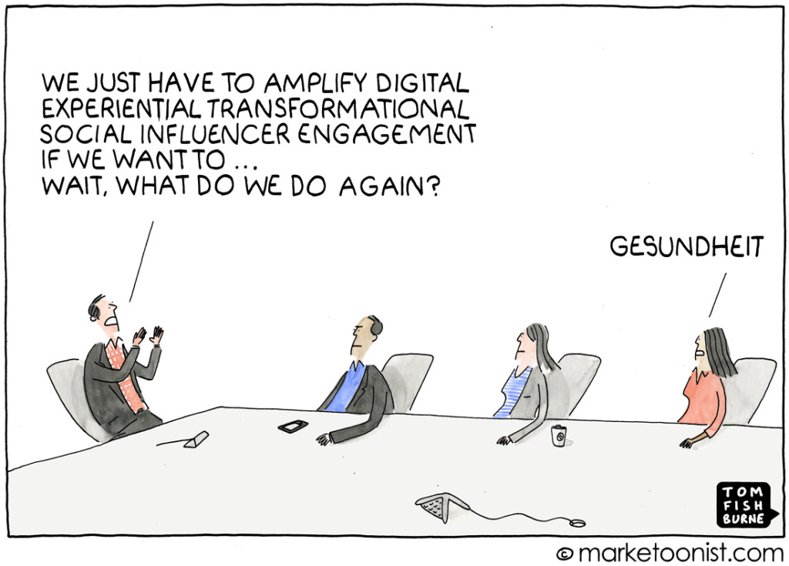  
  
Here’s a common scenario: A CEO hires a chief digital officer and stands up an innovation lab or team that’s separate from the company. The innovation team goes on safaris to discover the next new thing, such as artificial intelligence (AI), internet of things, blockchain and augmented reality.

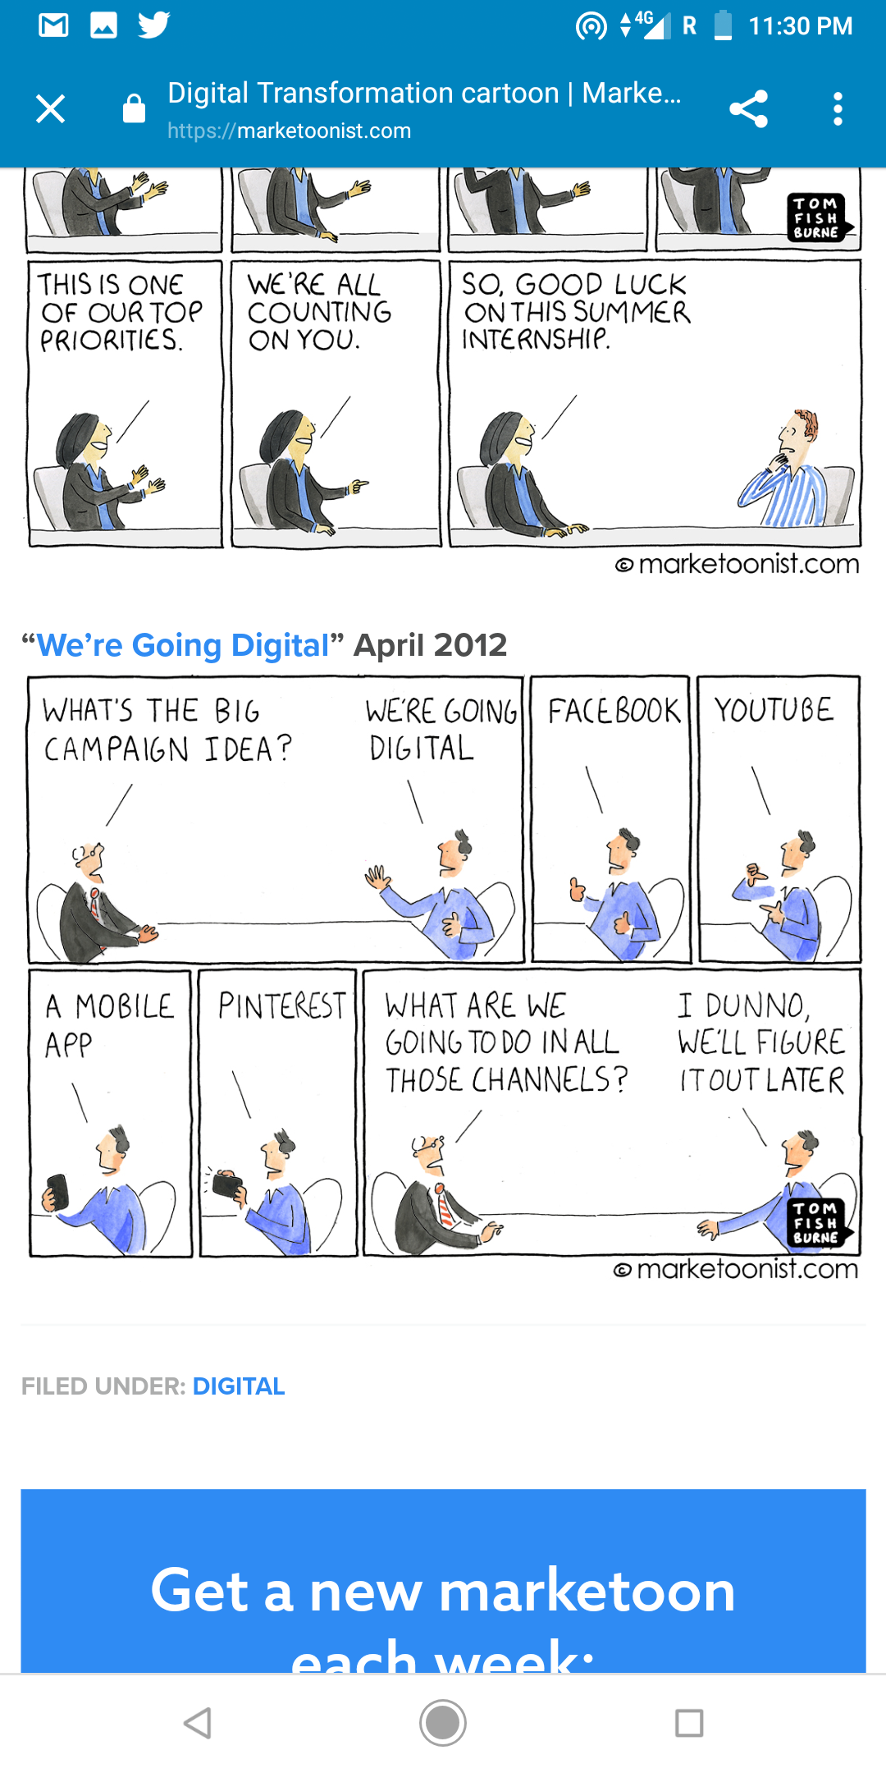

Based on a recent report around 80% companies claim to be undergoing through a digital transformation initiative in one or another form however only 27% businesses have placed a coherent digital business strategies.

As per a report from Forrester “The Sorry State Of Digital Transformation In 2018” Around 70% digital transformations are failing because people do not understand why the organization needs to change in the first place. As a matter of fact organizations have lost a significant amount of money on digital transformation but could not benefit from it. These transformation initiatives are only successful if there is a clear directive centered around delivering exceptional customer experiences. New technologies cannot be the end game. The ability to digitally reimagine the business is determined in large part by a clear digital strategy supported by leaders who foster a culture able to change and invent the new. While these insights are consistent with prior technology evolutions, what is unique to digital transformation is that risk taking is becoming a cultural norm as more digitally advanced companies seek new levels of competitive  
advantage. Equally important, employees across all age groups want to work for businesses  
that are deeply committed to digital progress. Company leaders need to bear this in mind in order to attract and retain the best talent.

Today, most of the organizations are engaged in digitization activities in the name of digital transformation. Most of the organizations consider digital transformation as simply IT upgrade.

Below are few myths about digital transformation:

1.Technological up-gradation  
2. Automation  
3. Renovation  
4. Refurbishing  
5. Repackaging  
6. Optimization and Enhancements  
7. Adding new channels

8. Reducing workforce and automation

People consider these basic activity as digital transformation and forget to take a holistic picture into mind. Hence this becomes the first step towards failure. However there are several reasons for the failure of the digital transformation. Based on multiple resources and perspectives, below are the major reasons for the failure of digital transformation.

1. **Fuzzy understanding:** Organizations have a very fuzzy understanding of digital transformation. A general perception towards digital transformation is more of upgradation, automation and IT related. If someone tries to understand the perspective of organizations who have implemented it successfully, they will give different definition of their digital transformation as it actually different for them and it is based on the requirement of their company. For some of them the transformation journey begins with the appointment of a Chief Digital Officer and many other supportive posts.

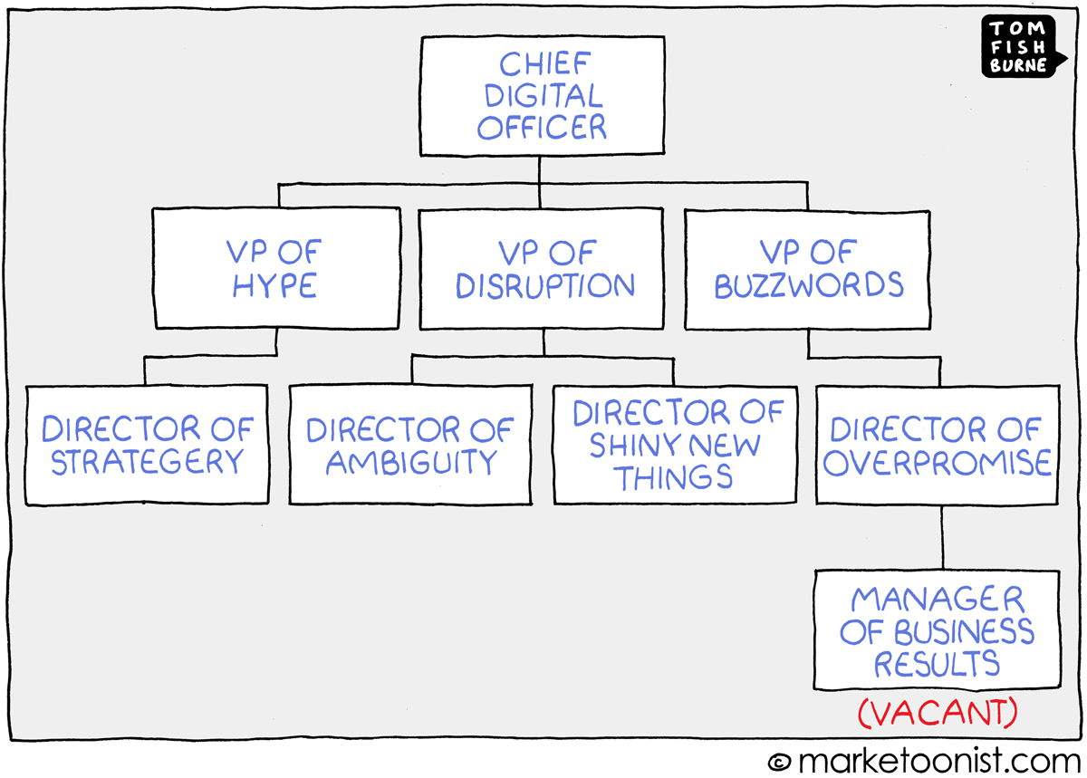

1. **Tech fast and Business Last**: Most of the digital transformation starts from technology. Once the technology becomes the anchor point for teams than people forget to take business and overall restructuring of the entire business. People miss the opportunity of thinking about a all new digital business model. As per the recent report by Deloitte and MIT Sloan, digital transformation is not really about technology but seeing technology as an enabler and then try to look at complex business problems to solve through technology. It further reinstates that “**Strategy, not technology drives digital transformation”.**

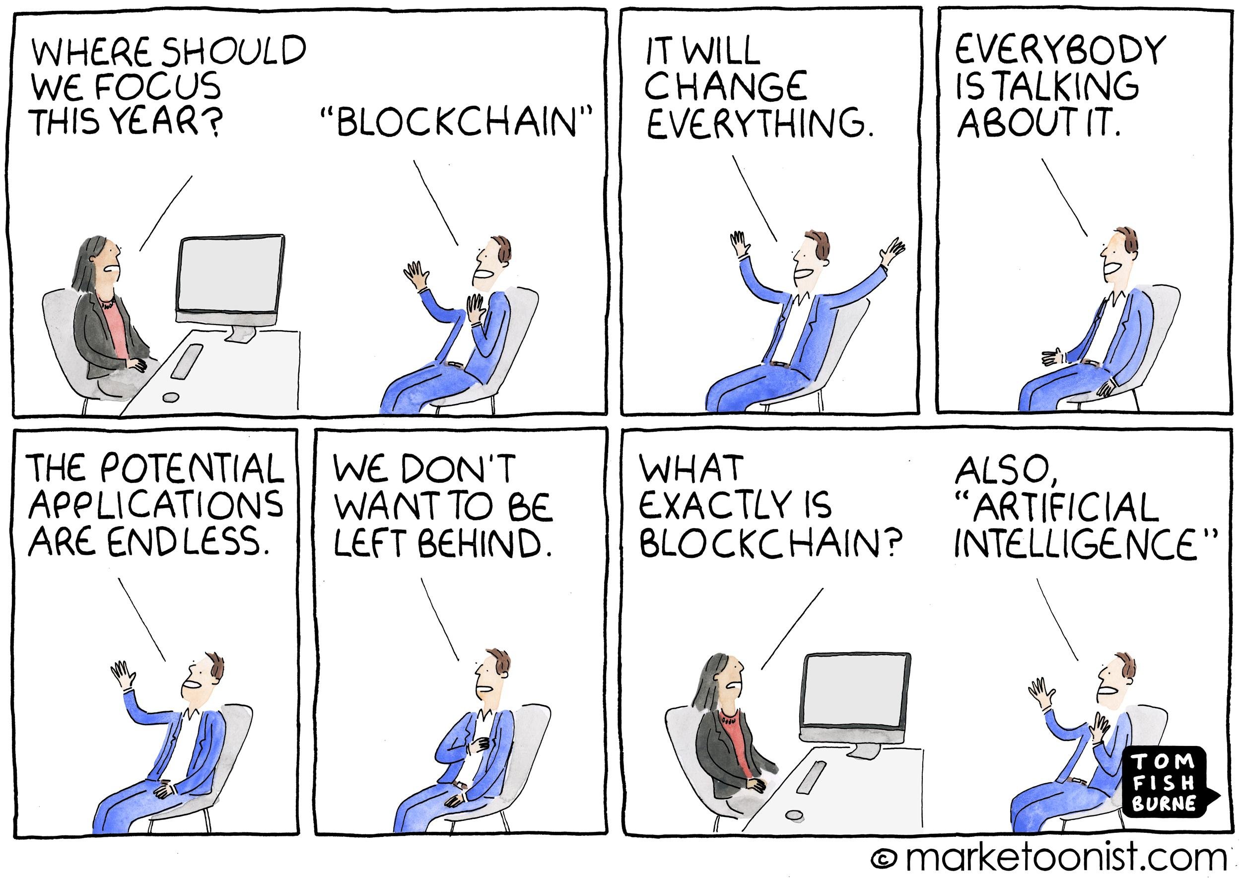

1. **Overlooking ecosystems**: Understanding the new economic rules can move organizations ahead, but only so far. Digital means that strategies developed solely in the context of a company’s industry are likely to face severe challenges. Traditional approaches such as tracking rivals’ moves closely and using that knowledge to fine-tune overall direction or optimize value chains are increasingly perilous. Digital-platform and -ecosystem economics upend the fundamentals of supply and demand, today companies with robust digital platforms are flourishing. In this ecosystem organizations try to create a platform where service provider and customer can not only connect but also gets autonomy to perform tasks at their convenience
2. **Missing the duality of digital:** The most common response to digital threats we encounter is the following: “If I’m going to be disrupted, then I need to create something completely new.” Understandably, that becomes the driving impetus for strategy. Yet for most companies, the pace of disruption is uneven, and they can’t just walk away from existing businesses. They need to digitize their current businesses and innovate new models.  
     
   Think of a basic two-by-two matrix such as the exhibit below, which shows the magnitude and pace of digital disruption. Where incumbents fall in the matrix determines how they calibrate their dual response. For those facing massive and rapid disruption, bold moves across the board are imperative to stay alive. Retail and media industries find themselves in this quadrant. Others are experiencing variations in the speed and scale of disruption; to respond to the ebbs and flows, those companies need to develop a better field of vision for threats and a capacity for more agile action. Keep in mind that transforming the core leads to much lower costs and greater customer satisfaction for existing products and services (for example, when digitization shrinks mortgage approvals from weeks to days), thus magnifying the impact of incumbents’ strategic advantages in people, brand, and existing customers and their scale over attackers.

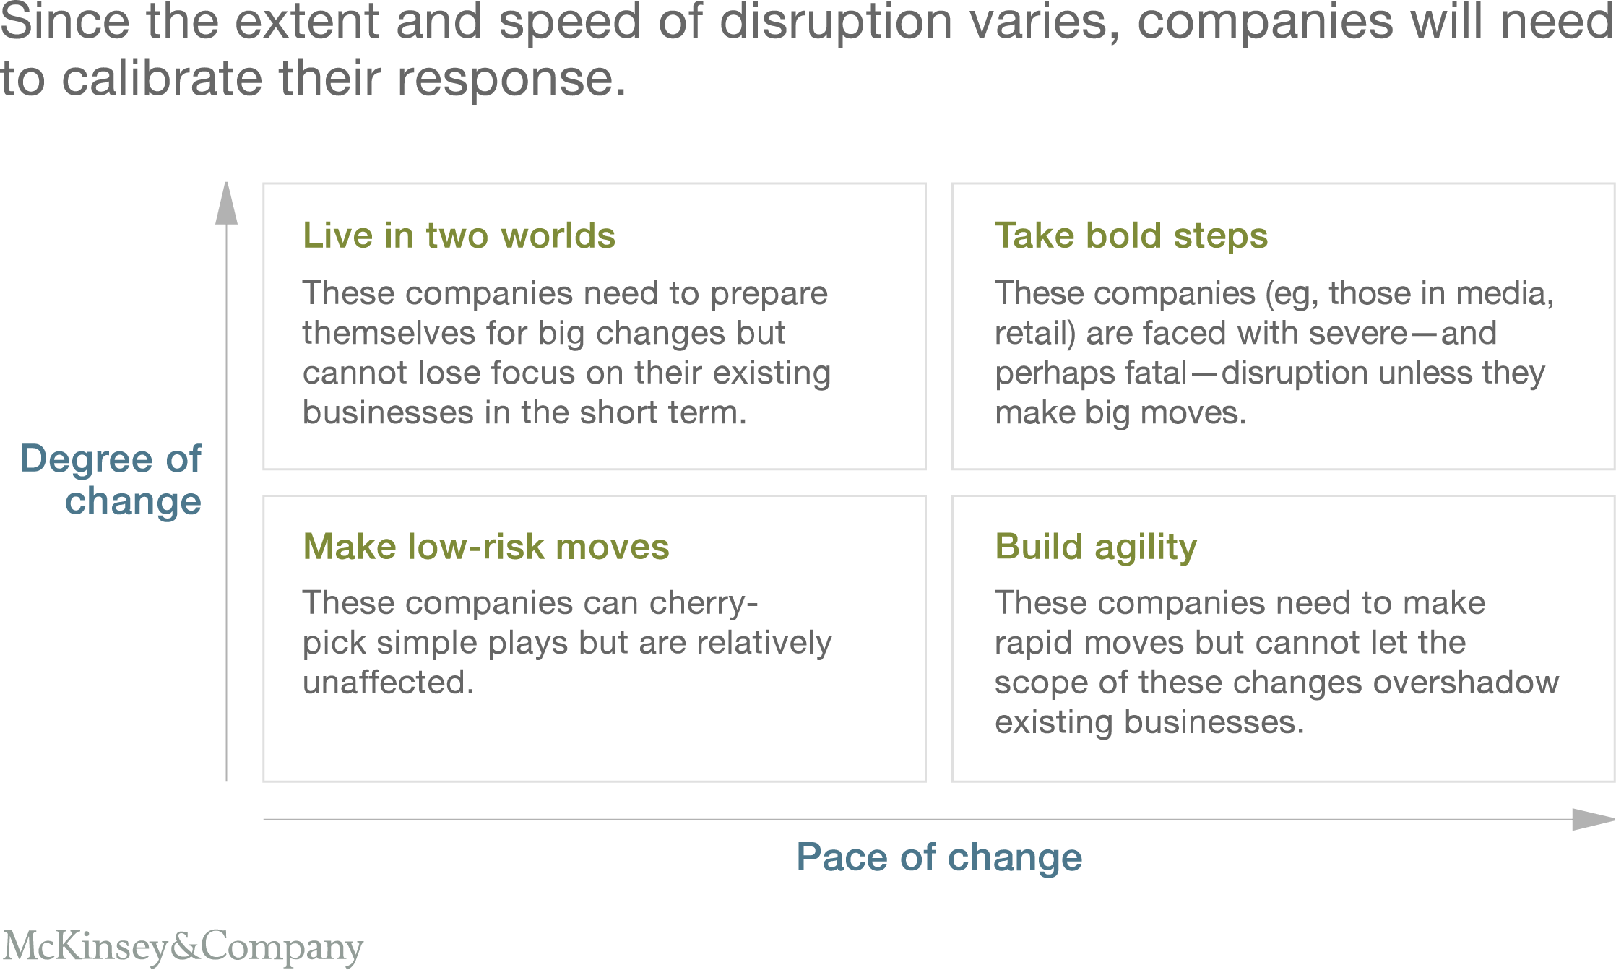

5. **Affinity with old Business model and revenue streams:** It’s very difficult for incumbent banks to let go off their traditional branch based business model. With the upcoming digital waves, banks need to understand that with the changing landscape in industry and consumer behaviour they need to look for new business models. Today, millennials do not prefer direct contact rather they interact with banking product through their smartphones. If the traditional way of interaction are changing then the business

model built around it must also change. But the reality is that a very smaller percentage of incumbents have accepted it and are ready to change.

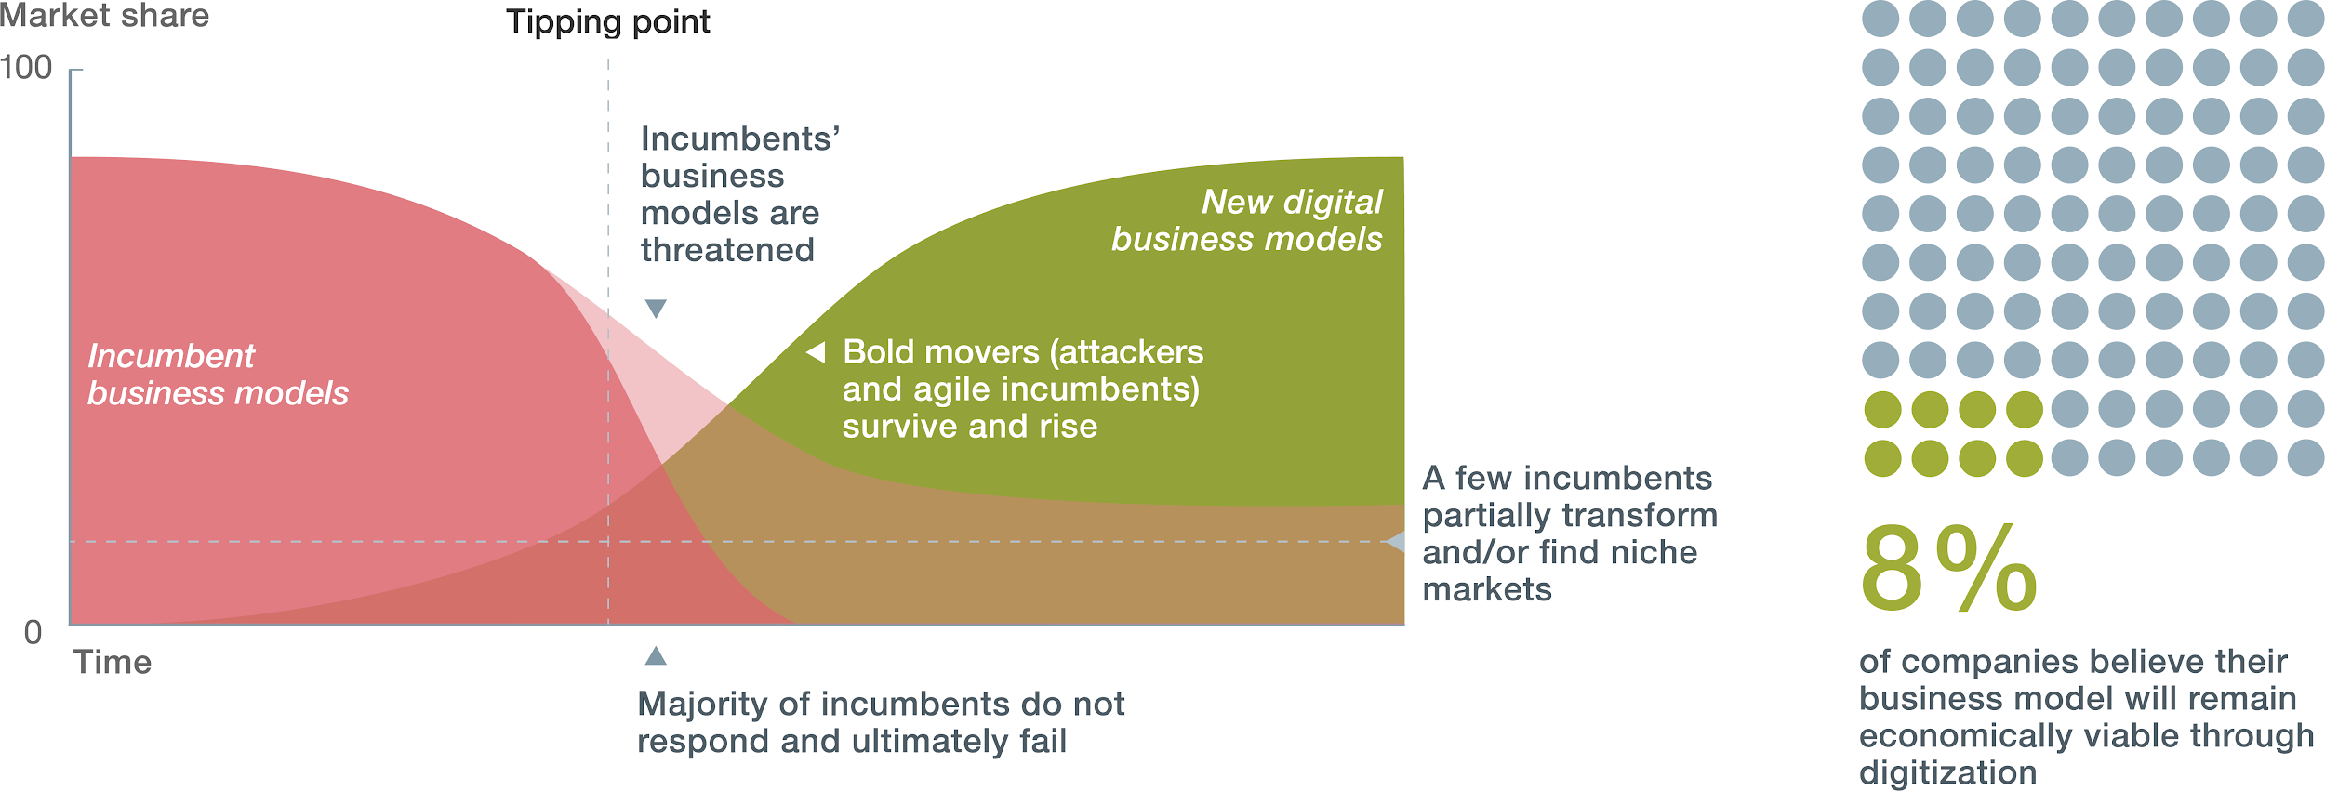

6. **Organizational Culture:** In a recent survey by Altimeter, it was found that around 63% organization feel that the major reason for the failure of their digital transformation is the failure to change the culture. In order to succeed in implementation of digital technology, organizations forget to change the culture for the people who are actually going to drive the system. Organizations forget to embrace the digital culture.

7. **Organizational Silos**: A business is very much like a human body. And just like a body, it comprises different parts that all play an active role in keeping the business alive, healthy, and moving forward. When departments constrict communication, stop sharing information and knowledge with one another, the business suffers. The standard model of organizational structure in a company involves compartmentalization of a business into several departments focused on their own respective objectives. This model, however, essentially leads to departments ignoring one another – a phenomenon referred to as the silo mentality. In the past, this organizational structure has indeed worked well, but in today’s dynamic world of business, it’s a plague able to destroy a company. Larger organizations like Societe Generale will often adopt the silo approach unknowingly. As a result, each department is often clueless about what other departments are doing, what goals they are driving towards, or how they are reaching them. In such environment it becomes very difficult to embrace the change and drive a healthy transformation where different department are not ready to cooperate with each other. Although, it would be dishonest to blame people entirely, sometimes the differences in technological advancements in term of tools and application also become major hurdle in accept the change.

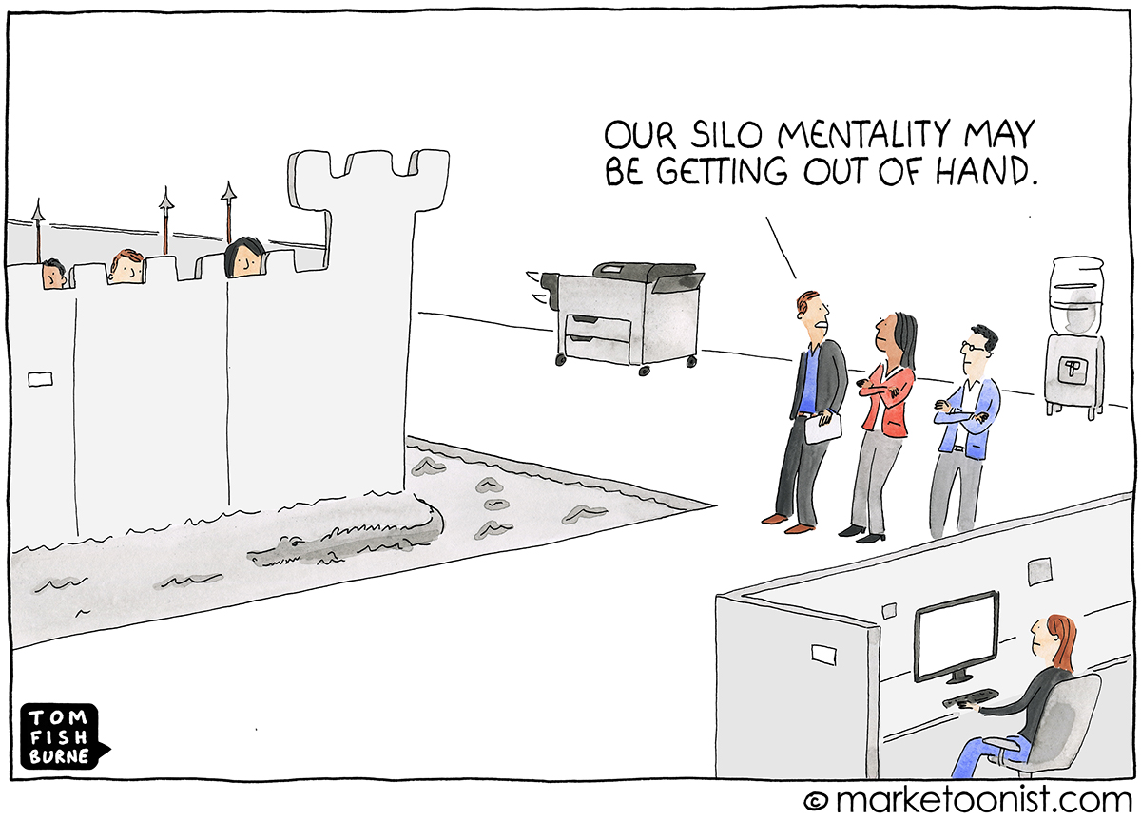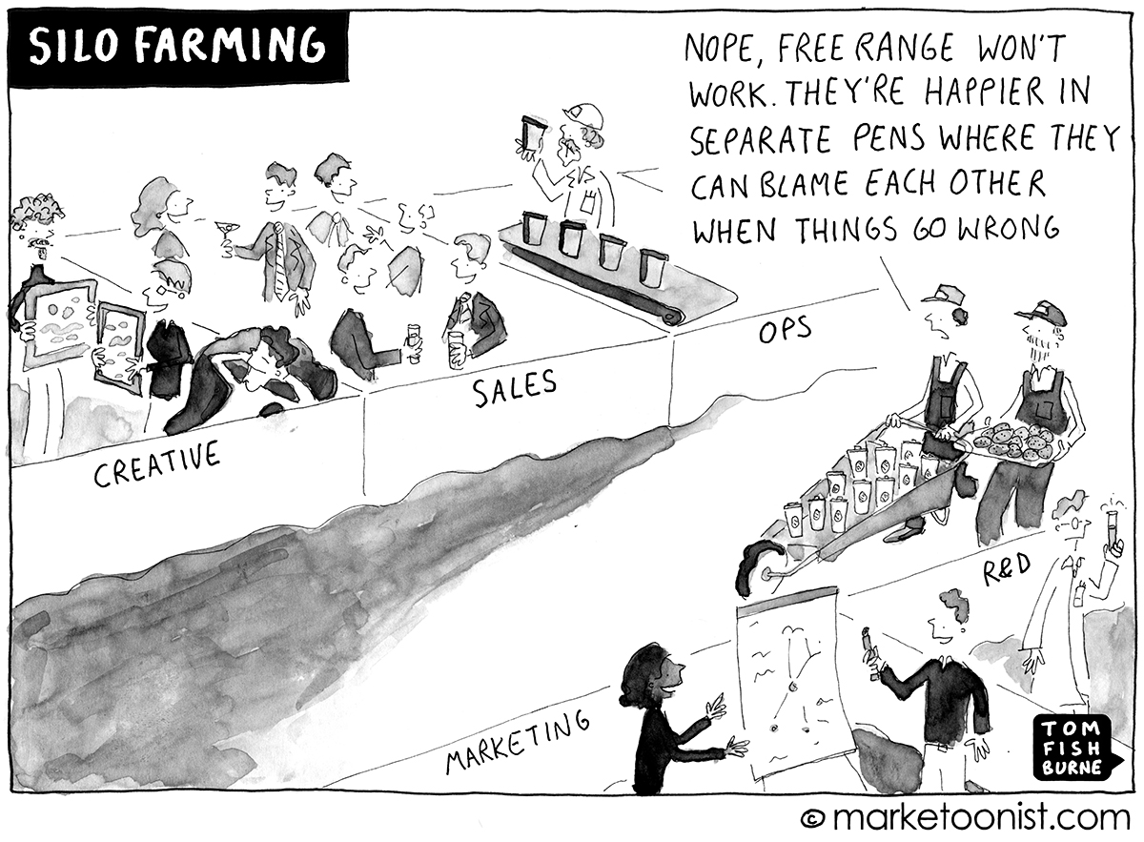

8. **The Hypocrisy**: While businesses cite “evolving customer behaviors and preferences” as the top driver of digital transformation, fewer than half invest in understanding digital customers. Organizations are still taking inward out approach to understand customer rather than taking outward in approach.

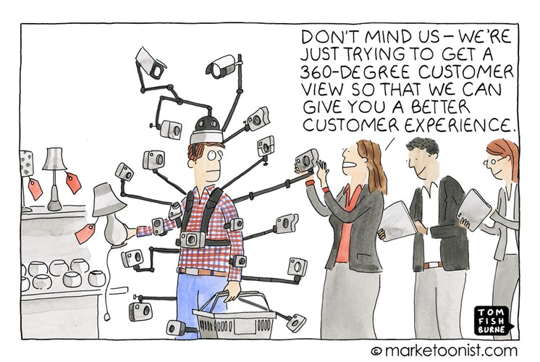

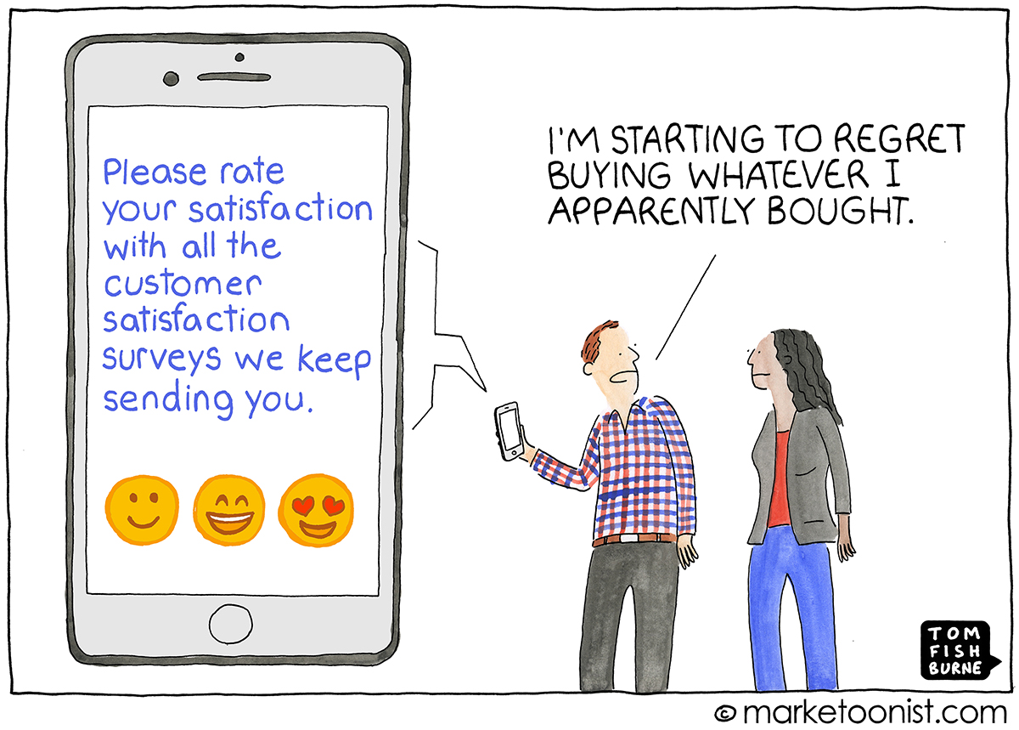

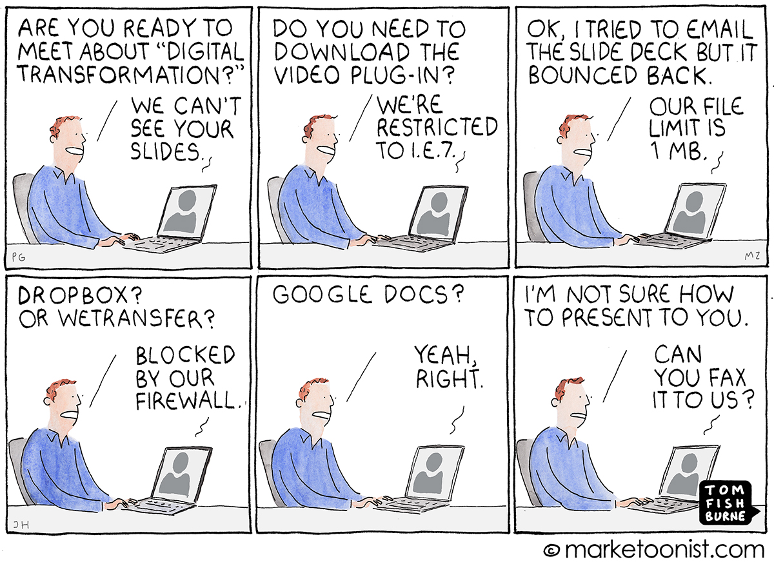

Public relations may be working towards reaching the local people while the HR team is trying to source employees from different cities or countries. Instead of working in unison to achieve the company’s aims, the two departments are focused on their own objectives, never meeting the main goals of the company.

**Organizations are just jumping into Digital by replicating models of competitors without even understanding the contextual requirement.**

**What is the truth of Digital Transformation?**

As most of the reports and articles claim higher rate of failure of digital transformation projects and on an average it goes upto 70%. If someone tries to do a second level analysis, it can be seen that these reports are based on a limited sample of data set generally upto 100 industries. These surveys and questionnaires are sent to companies on mail and asked to respond on mail. No research digs down the underlying reasons for the failure of digital transformation. This brings to ultimate question that what needs to considered failure or what needs to be succeed.

Moreover, contrary to the established belief of a project that it has an end, Digital transformation does not have an end , it is a continuous process. As technology keeps evolving with time hence continuous efforts for continuous digital evolution. Organizations need to focus on digital strategy and then work towards achieving the digital goal.

**Primary Research :**

**Constraint:**

As per the organizational requirement the nature of the project was to explore the Digital Transformation for a legacy bank and understand the holistic challenges pertaining to the organization. Considering the huge scale of the project a local business line was finalized to understand the challenges with the existing system.

Objectives:

1. To understand the general trends of challenges in different business lines
2. To understand the different practices followed by organization

Methodologies:

1. Expert Interview - Industry Perspective
2. Brainstorming workshop
3. Observational Study

**Objective: 1.**

Understanding Digital:

One of the biggest challenge in understanding the Digital Transformation is to understand the core of the word such as Digital. Digital being an ever evolving term has different connotations attached to it. Most of the people in organization consider digital being the synonym for technology. Hence to understand the actual definition of digital, a small focus group of 7 people were arranged and asked to discourse over their understanding of digital. This discussion was a smaller discussion moderated by author to gain broader idea about the perception around digital. 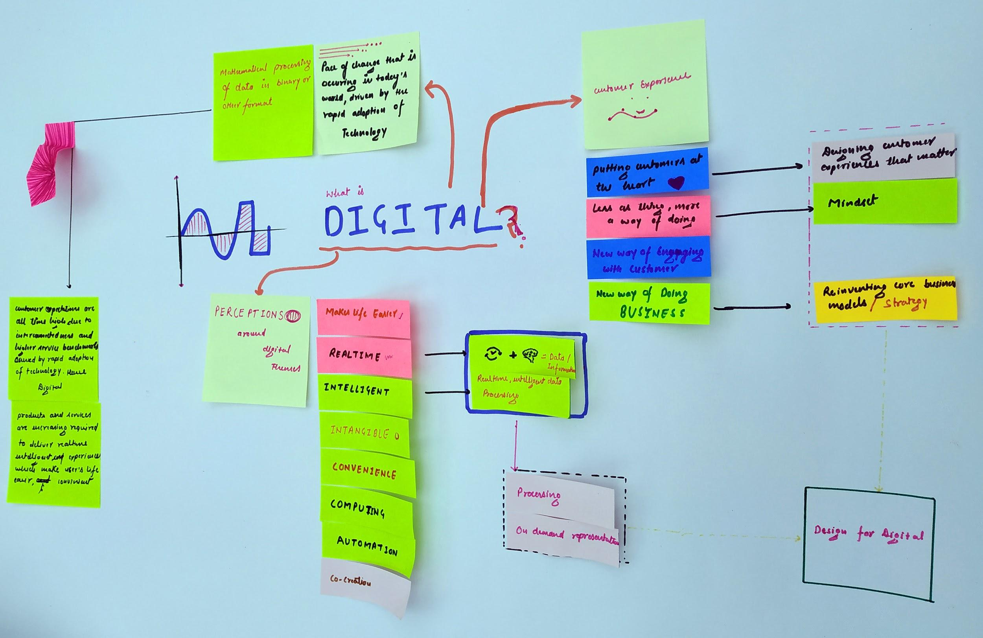

**Digital** : Setting engineering definition aside the term Digital itself has a very wide connotations to it. From consumers perspective it is simply about convenience, making life easier, intelligent, real time while from the business perspective, it opens new ways of engaging with customers, new ways of doing business, it is about having a digital mindset first, it is about putting customers at the heart of everything. Surely, digital has a very wide understanding among the consumers and service provider but the essence of Digital lies in understanding at a very fundamental level. If a summary of the exercise has to be given then it can be simply put in these words.

**Digital is the manifestation of pace of change that is occurring in today's world, driven by the rapid adoption of technology.**

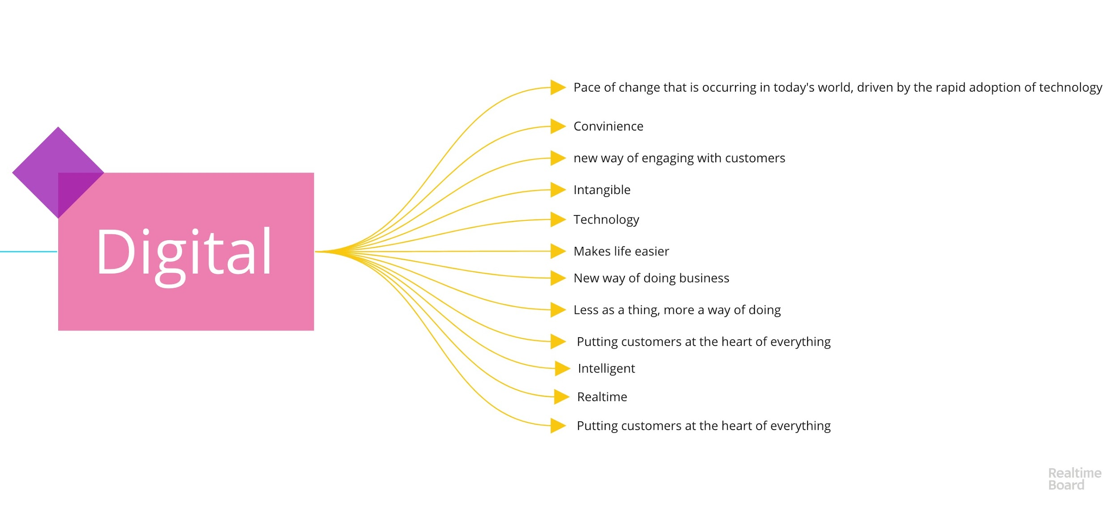

**Expert Interview to understand the Digital Transformation:**

Subbu Iyer: Subbu is the founder and currently the CEO of Hreem, a design and digital transformation consultancy. In past he has been associated with Wells Fargo as Senior Vice President, Wipro and founded two another startups. Considering the diverse experience in Banking, design and Digital transformation, Subbu shared his experience, vision and challenges in industry pertaining to the different approaches to digital transformation.

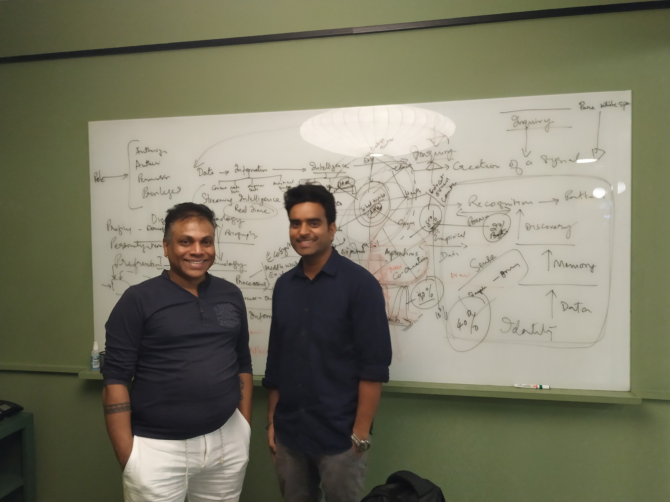

Subbu puts Digital Transformation as the integration of Life, Digital and Information Technologies. Though technology is impacting us in many spheres of life but he categorises specifically with different spheres.

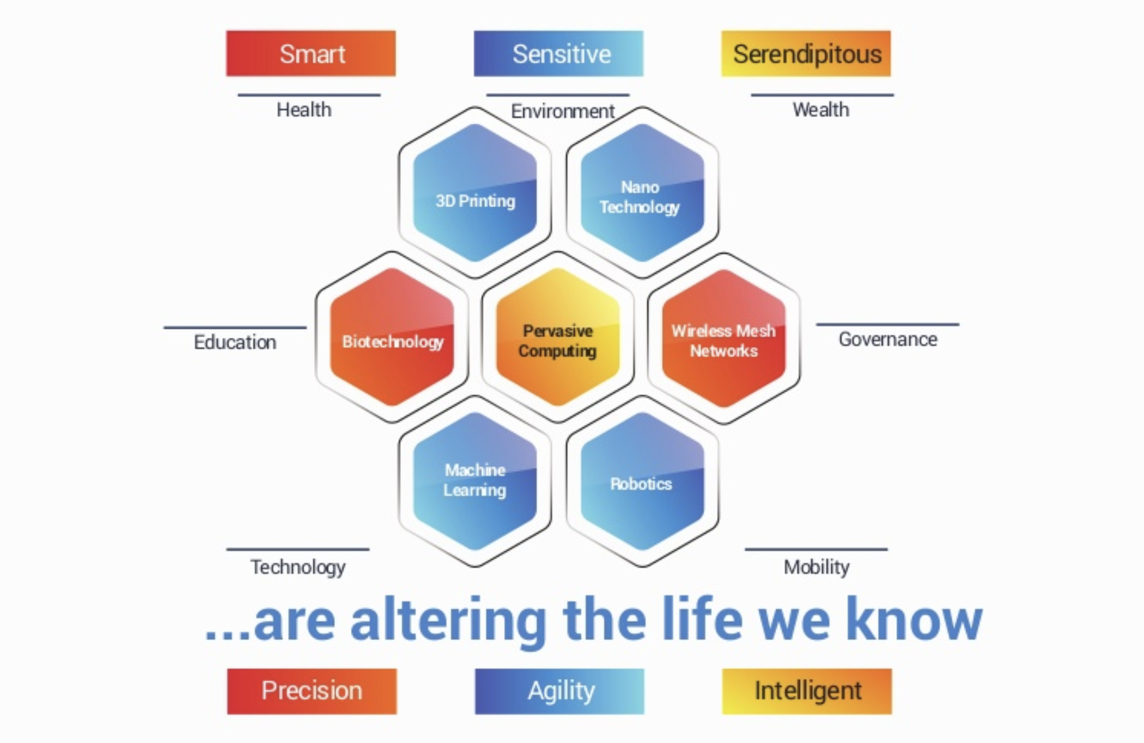

Organizations, who have enjoyed the fruit of standardization in past generation business model of uniformity across strategy, process, capabilities, technology and infrastructure will not enjoy anymore. Enterprise will chose their scale and structure of positioning in this manifestation of technology depending on their capabilities to visualise, execute and participate. It is inescapable to recognize that design thinking mindset is required that allows decision making from the both perspective, determining future and making things work in present with precision.

Hence, enterprise would need to address these critical challenges from design thinking perspective.

Highlights:

* Digital transformation is the integration of life, digital and information.
* Technology transformation is impacting 7 spheres of life namely.
* Modern paradigm of customer focus is not just fulfilling expectations only but targeting aspiration to increase the strategic value.

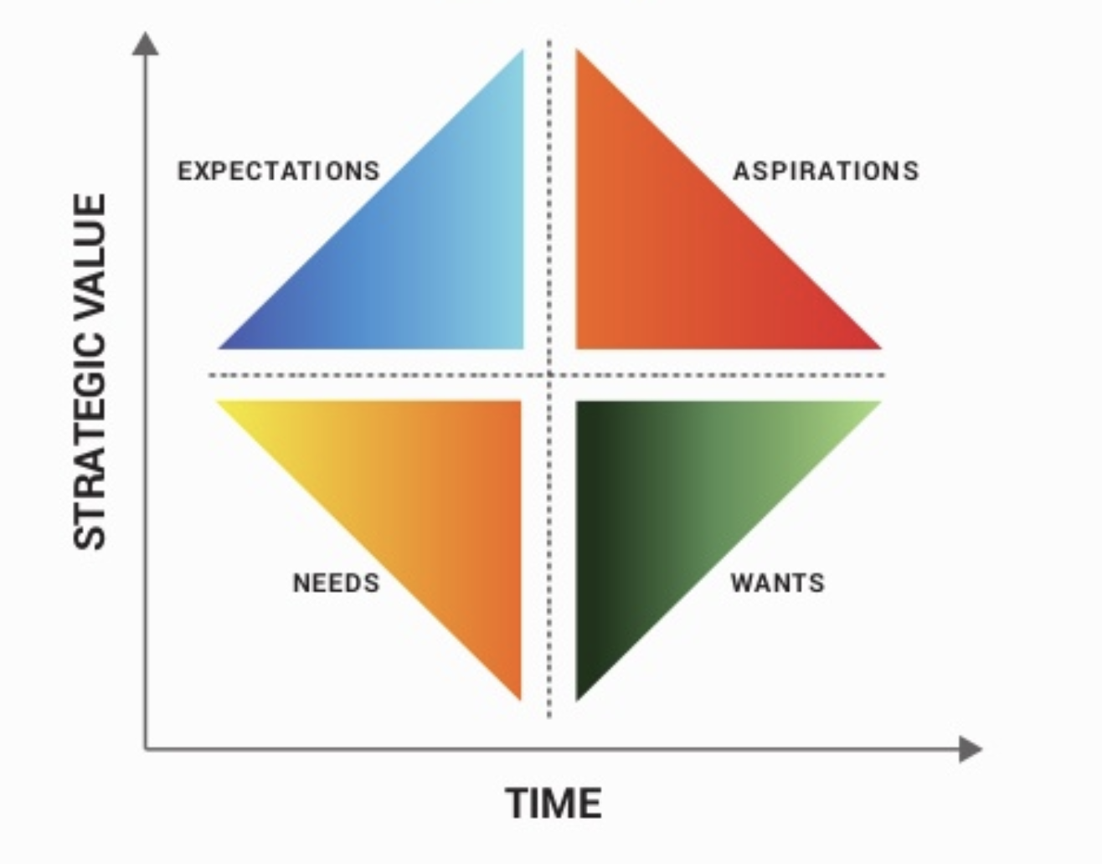

Brainstorming Workshop:

The project was undertaken with the Indian subsidiary(SGGSC) of Societe Generale bank. SGGSC falls under the resource group (RESG) of bank which provides all the resources required to run the bank. Societe Generale operates in three layers architecture mainly front office, middle office and back office. Front office directly deals with clients, customer, investors etc. These clients customers can be business to business(Corporate Banking, High net worth individuals) and business to customer(Retail banking customers). Middle office is immediate support for banking operations happening at the front end. Back office is generally offshore which supports middle and front end operations by providing support in different spheres like services in the areas of Application Development and Maintenance, Infrastructure Management, Business Process Management, and Knowledge Process Management, to Societe Generale's business lines around the world.

To get a deeper understanding of the organizational challenges specially related to technology, system and operations, a brainstorm workshop was conducted with the stakeholders of an internal business line. The particular business line supports the backend operations of the Societe Generale’s internal unit named as Capital Management Agency. In particular, it is responsible for clearing of trades from the system and feeds it into the general ledger. It takes care of clearing of all the kinds of trades happening on different international stock exchanges in three different regions namely AMER(American Markets), EMEA(European Markets) and APAC(Asia Pacific).

The brain storming session was a 3 hours session moderated by the author. Some of the major teams were clearing team, technical support team and application maintenance team. The invitation for the workshop was sent to 14 people but only 8 could join us physically (Location Chennai ) and rest joined on the skype.

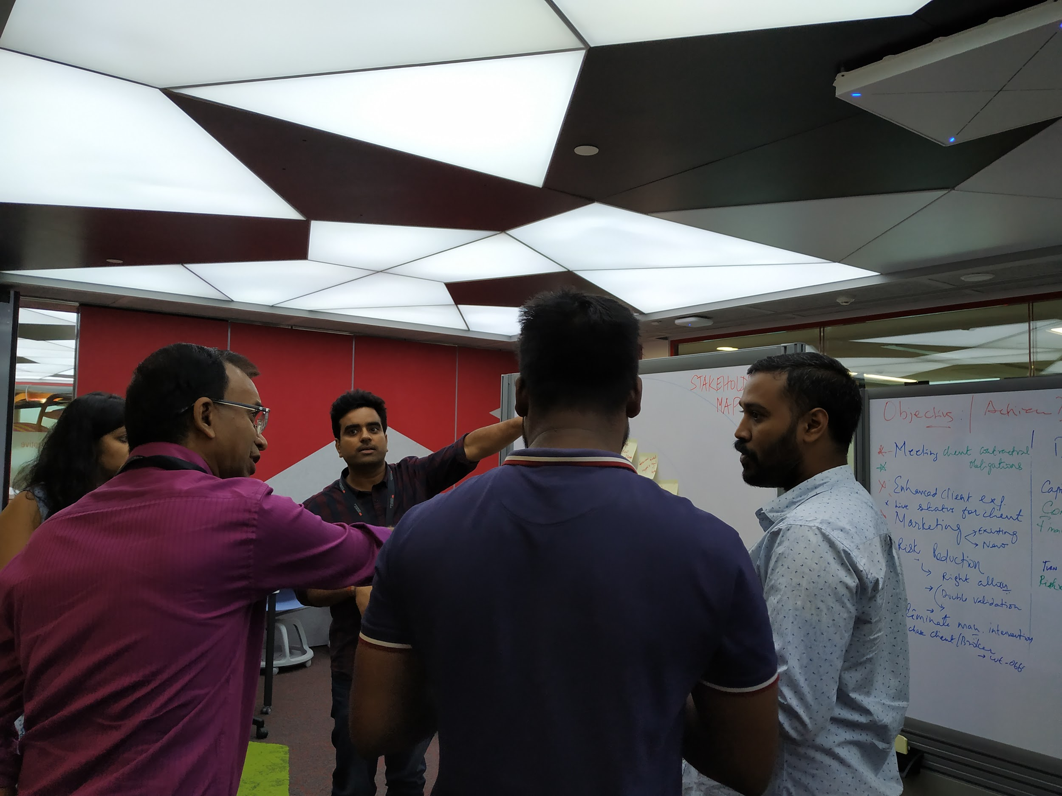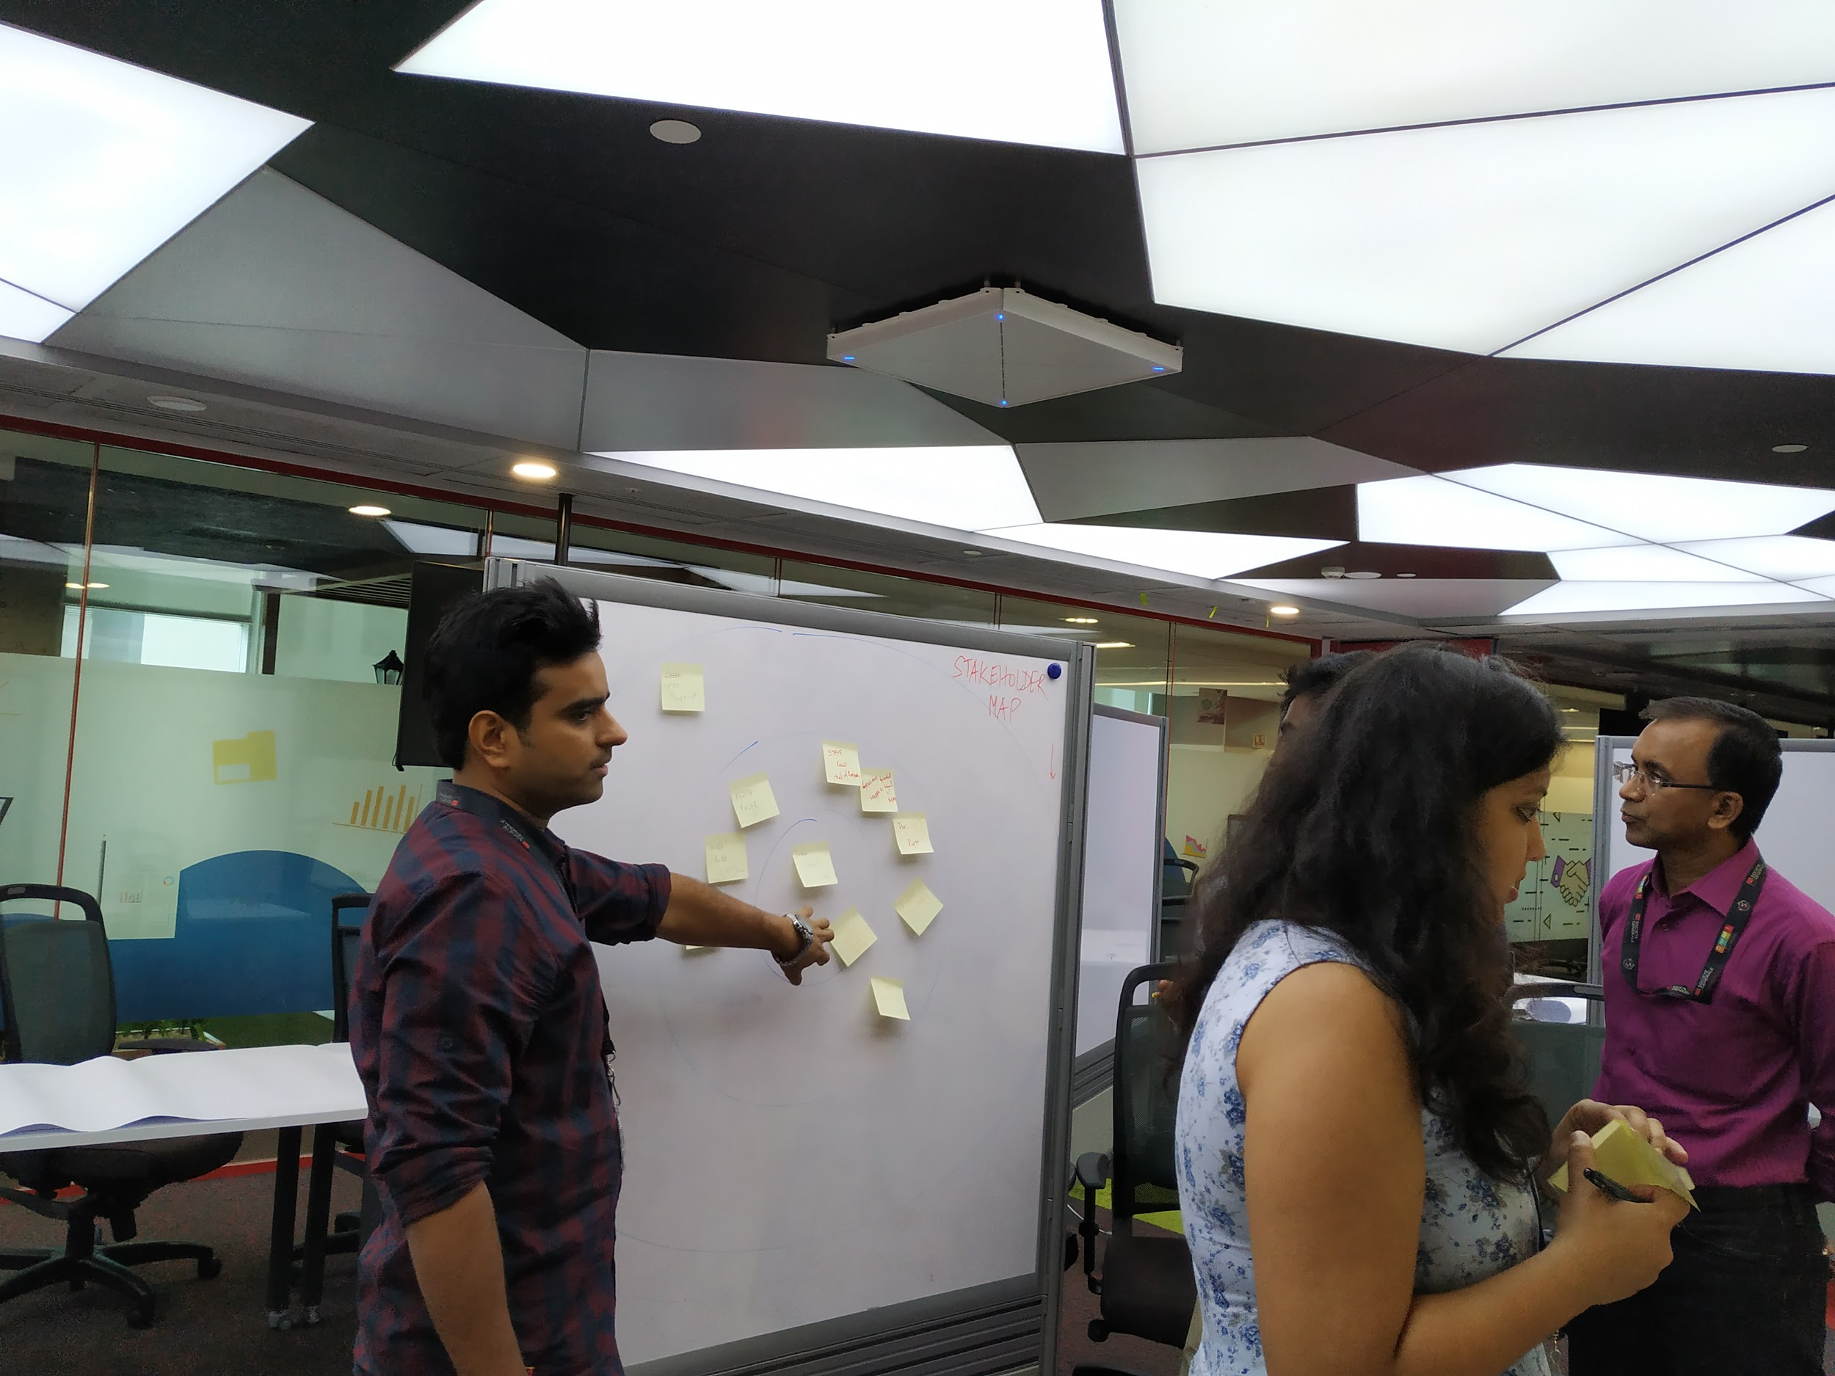

*The 2018 IT whitebook by RESG- Transformation, Process and Information systems gives a global view of the 2020-2022 stakes and convictions for the Societe Generale information system.*

There are few major challenges identified during the workshop.

1. **Legacy Infrastructure**: The major hurdle in front of internal teams is to move away from the legacy infrastructure. Operations teams are still facing issue related the upgradation of infrastructure due to the compliance related challenges. Even assuming that compliance and regulatory requirements are filled, there would be issues related to security. One of the major challenge is to integrate the legacy tools and newly procured application/software. There have been cases where team is completing certain migrations from almost 3 years. At the heart of the issue is the IT machinery used by the bank, which is a tangled web of legacy systems and modern software. Underpinning these systems is the Common Business-Oriented Language, better known as COBOL. This is a programming language first developed in 1959 that still drives the mainframe computers. Though Mainframe is still considered to be the one of the secure system but it becomes eventually a blocker in certain system upgradation. Due to these major factors it becomes difficult to embrace change.
2. **Distributed Control** : Generally, a simple process has to pass through multiple checkpoints, distributed teams and stakeholders. As the process flows from one end to another end it gets stuck at different checkpoints due to approvals and shared control for different stakeholder. In systems understanding, As the control remains distributed to the different parties, it brings entropy into system and ultimately introduces the delay.
3. **Redundancies**: Some of the workflows were created long back and are being followed even today. Many people understand that there are steps and sub process inside the process which are redundant and can be removed easily but are not being removed still. The major reason for such behaviour is the uncertainty about the owner of the process and inability to estimate the actual impact.
4. **Difference in geographical locations:** Distribution of teams at different geographical location: One of the major hurdle for the teams is to coordinate with different teams spread across different geographies. The structure is also causes issues related to understanding the language of different regions.
5. **Accommodating client requirements:** Due to the last minute client requirement changes, teams has to follow agile methodology. Also these changes are sometimes not only fulfilling internal regulations and compliances but the national compliances.
6. **Customer Service Compliances:** Due to internal NPS ratings, teams are under pressure to maintain a minimum NPS rating.

**In depth Interview:**

After understanding the challenges from a team level, an in depth interview was conducted with one of the member named Rohit (Imaginary name due to anonymity) from Market to Market(MTM) team. The main role of the team member is to do valuation of collaterals for OTC( Over the counter) markets. The particular team member was selected because of his interest in digital transformation. Rohit had previously discussed with the author about the digital transformation project he has undertaken. Some of the major highlights from the discussions are described below.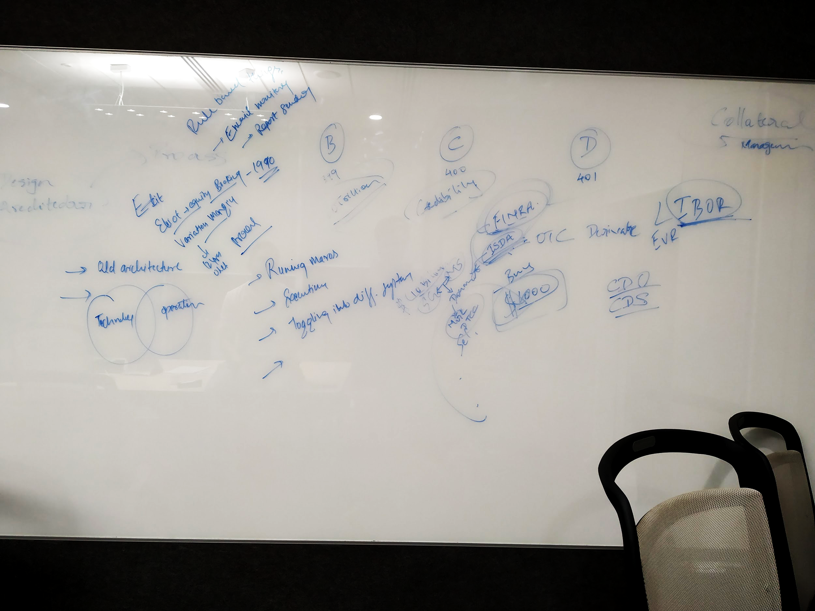

1. **Gap in understanding of operations and Technology**: As per the structure of the organization, teams operate in different divisions. Basically for a standard project there would an operations team and there would be a technical team. Operations team performs regular functions on tools, process, flows while technical team supports and builds these products. Operations team does this function to ensure working of different back office related activities. In current scenario and structure, operations team faces challenges in daily activities be it a related to performing a redundant task, regulatory tasks etc. Operations team, not being equipped with technical skills feels enability. On the other hand technology team feels that this is beyond their job responsibilities and sometimes they are not able to understand the exact issues faced by operations team. Hence there lies an opportunity to bridge this gap by bringing talent with holistic understanding of the operations and technology.
2. **Outdated Tools:** Societe Generale being a legacy organization have tools dedicated for different processes and functions. Some of these tools like Eliot (Equity Booking) have become outdated and still being continued from almost 25 years. It becomes a tedious task to perform operations on such tools. These tools reduce overall productivity of the team and force team to perform redundant activities.
3. **Outdated Processes:** Particularly for Rohit’s team, there are obsolete processes which are in place from almost 12 years. Generally, nobody has questioned the status quo from years and learn to adapt with the system by assuming that this is the way system works. Since, Rohit has worked with Morgan Stanley before so he understands the system of both the companies and is able to compare. As both the organizations are operating in same spheres and work under same kind of regulations hence the final outcome from both the companies is expected to be same but these companies have different approach to achieve this. Societe Generale is operating on platforms, tool and processes which are almost a decade older than of its competitors.
4. **Redundant Tasks:** Being a bank, organization has to follow many rules and regulations which have been imposed by regulatory authorities like FINRA(Financial Industry Regulatory Authority), SEBI(Securities and Exchange Board of India), Fed (Federal reserve system) to avoid defaults, risky loans etc. As Societe Generale deals in OTC (Over the counter) trading as well hence bank has to send reports, statements to different regulatory authority for business continuity. Traditionally, Operations teams have been performing these tasks which are generally generating and sending reports to client and regulatory authorities, executing macros, rule based executions and extensive email monitoring etc. These tasks are monotonous and become pain points for people who are actually generating data.

Though individuals are trying to implement digital transformation related activities at team level and there are special heads inside few business lines who are responsible for transformation. Digital transformation is occurring in fragments and chunks in different business lines but there is no organization wide roadmap to accomplish.

**Observational Study:**

System aspects: Alignment from top to middle

Digital Transformation in Societe Generale:

Societe generale categorizes digital transformation into three aspects mainly.

1. **Digitization**: Societe Generale sticks to continuing the same activities while optimizing them through the use of technology by promoting activities like adding e-commerce, digitizing customer service, expanding online communications, improving methods and internal processes through technology…this type of initiative contributes to strengthening a company’s performance, while changing neither its offer, nor its long-term strategy. In the insurance sector, for instance, this involves everything from allowing clients to subscribe online, to managing contracts and claims through digital interfaces, to developing a company presence on comparison websites and social media, etc.
2. **Improvement through technology** : Improving the offer and core business of the company; in other words, beginning the company’s transformation without yet changing its business model or disrupting market conventions. During this phase, the company takes advantage of technological opportunities: opening new markets, developing new offers made possible by technology, exploring related sectors and business activities, organizational changes and bringing the company up to speed digitally. Whether a retailer opens a marketplace, or an insurer launches a reputation protection service or fits vehicles with a black box to offer rates based on actual kilometres travelled, the opportunities for growth are many, and impact the company’s strategy and business model up to a certain point. This progress, however, still relies on existing market conventions, and does not attempt to re-evaluate the company’s core business.
3. **Disruption**  
   In order to face the challenges posed by newcomers, companies must go further, reconsidering their core activities and business model in view of the real needs of individuals, This is the strength of digital disruptors. It involves reassessing the way the company does business in order to identify its unique capability or skill, its core competency. In the case of insurers, it is their actuarial skills that make them indispensable: quantifying risk is a unique and highly useful competency. Next, companies should study the needs of individuals, placing more emphasis on their core business than on market conventions: for insurers, exploring the connection to risk, rather than to insurance products. This is how disruptive innovation, the ultimate goal of digital transformation, is born: a radically new offer, digitally driven and based on the real needs of individuals, regardless of market conventions.  
     
   **Digital transformation is, in reality, a business transformation made necessary and possible by technology.** Necessary, because individuals have new needs and new expectations. Possible, because technology allows companies to offer unprecedented and lucrative responses to these needs.

**Highlight:**

* Though like most of the incumbent banks, Societe Generale has covered a long journey in Digital Transformation, but the ground reality still remains same. The alignment of vision set by leadership for digital transformation is found rarely. On a system level the transformation vision is set by leadership but hardly reaches employees. It generally comes in form of small software and technology oriented projects.
* Societe Generale keeps Open, Agile and Focus as the guiding principles but yet to be realized on seen or acted upon.

**Risk Aversion:** In legacy organizations like century-old banks, a culture of Risk Aversion is quite prevalent which ultimately prevents employees  
 and leadership to take the risk. The culture of being happy with the existing state and giving up on the innate desires for taking risk and adventure have somewhere lost. Picture a management team, composed of highly accomplished individuals with long tenures at the company, gathering at the annual planning meeting. The CEO has been in place for five years, business performance has been strong and Wall Street has rewarded shareholders handsomely. Yet the CEO has a nagging perception that forces gathering in the marketplace threaten the company’s long-term outlook. Choices made now will determine the ability of the organization to respond in the future. What is his team likely to do?  
Research has shown that as individuals, we possess a negativity bias. Simply put, our fear of losing is greater than our thrill of winning. We notice and react to angry faces in a crowd more readily than we do happy faces. When offered a bet with equal probability to win or to lose, the average person requires a gain twice the value of the potential loss before the bet is accepted.  
  
This tendency to prefer avoiding losses over achieving equivalent gains drives powerful risk-averse behaviors that can hold us in place like gravity, leading us to prefer the status quo even when change is very much in our best interest.  
  
At an organizational level, this tendency increases exponentially. The compounding effect of risk-averse behaviors across thousands of individuals — each preferring known working patterns over the perceived risk introduced by change — generates overwhelming organizational inertia. The end result: we don’t change, and the organization suffers.

**Conformity of Risk Aversion:** With existing businesses up and running, leadership does not anticipate the urgency of change and avoid going against the inertia as it becomes difficult for leadership to lose a comparatively better position than an uncertain future. This behaviour of risk aversion becomes prominent in organization and people start fearing the change. When people in group avoid a more risky and uncertain situation then it becomes the general trend across organization. For an individual to see opportunity instead of risk in transformation makes them to hold their thoughts and remain in current state. Despite their better judgment, some people feel themselves nudged into alignment with colleagues. Instead of pushing back, they keep their heads down. Rare is the individual who has the courage to stand alone. When one individual get influenced by the behaviour of another individual and henceforth it becomes a norm. Slowly this behaviour creeps in to the nerves of the organization and ultimately becomes the conformity of risk aversion.

Analysis Phase:

Though technology is changing at an exponential growth but many organizations have benefitted and flourished. Some organization could not match the pace and perished while others became the fastest billion dollar companies. Based on the results of primary and secondary data, it is evident that organizations need to realign their strategy and look towards reaping the benefits of technical progress. It’s not only the technology that has changed the business landscape but the combination of technology and a few aspects.pana

To list down a few:

1. Amazon did not kill the retail industry. They did it to themselves with bad **customer service**.  
  
2. Netflix did not kill Blockbuster. They did it to themselves, with their **ridiculous late payment fees**.  
  
3. Uber did not kill the taxi business. They did it to themselves, with their limited number and fare control.  
  
4. Apple did not kill the music industry. They did it to themselves by forcing people to buy full-length albums.  
  
5. Airbnb did not kill the hotel industry. They did it to themselves with limited availability and pricing options.

At face, it looks like that technology has killed the business but the truth is that the inability to adapt to the new environment has. Companies have sensed this change and trying to adapt to the digital pace. In hurry, most of the organizations have jumped into digital transformation without understanding. Organizations are simply replicating models of competitors without even understanding the contextual requirement.

https://www.businessillustrator.com/product/digital-transformation-cartoon-explainer-kit/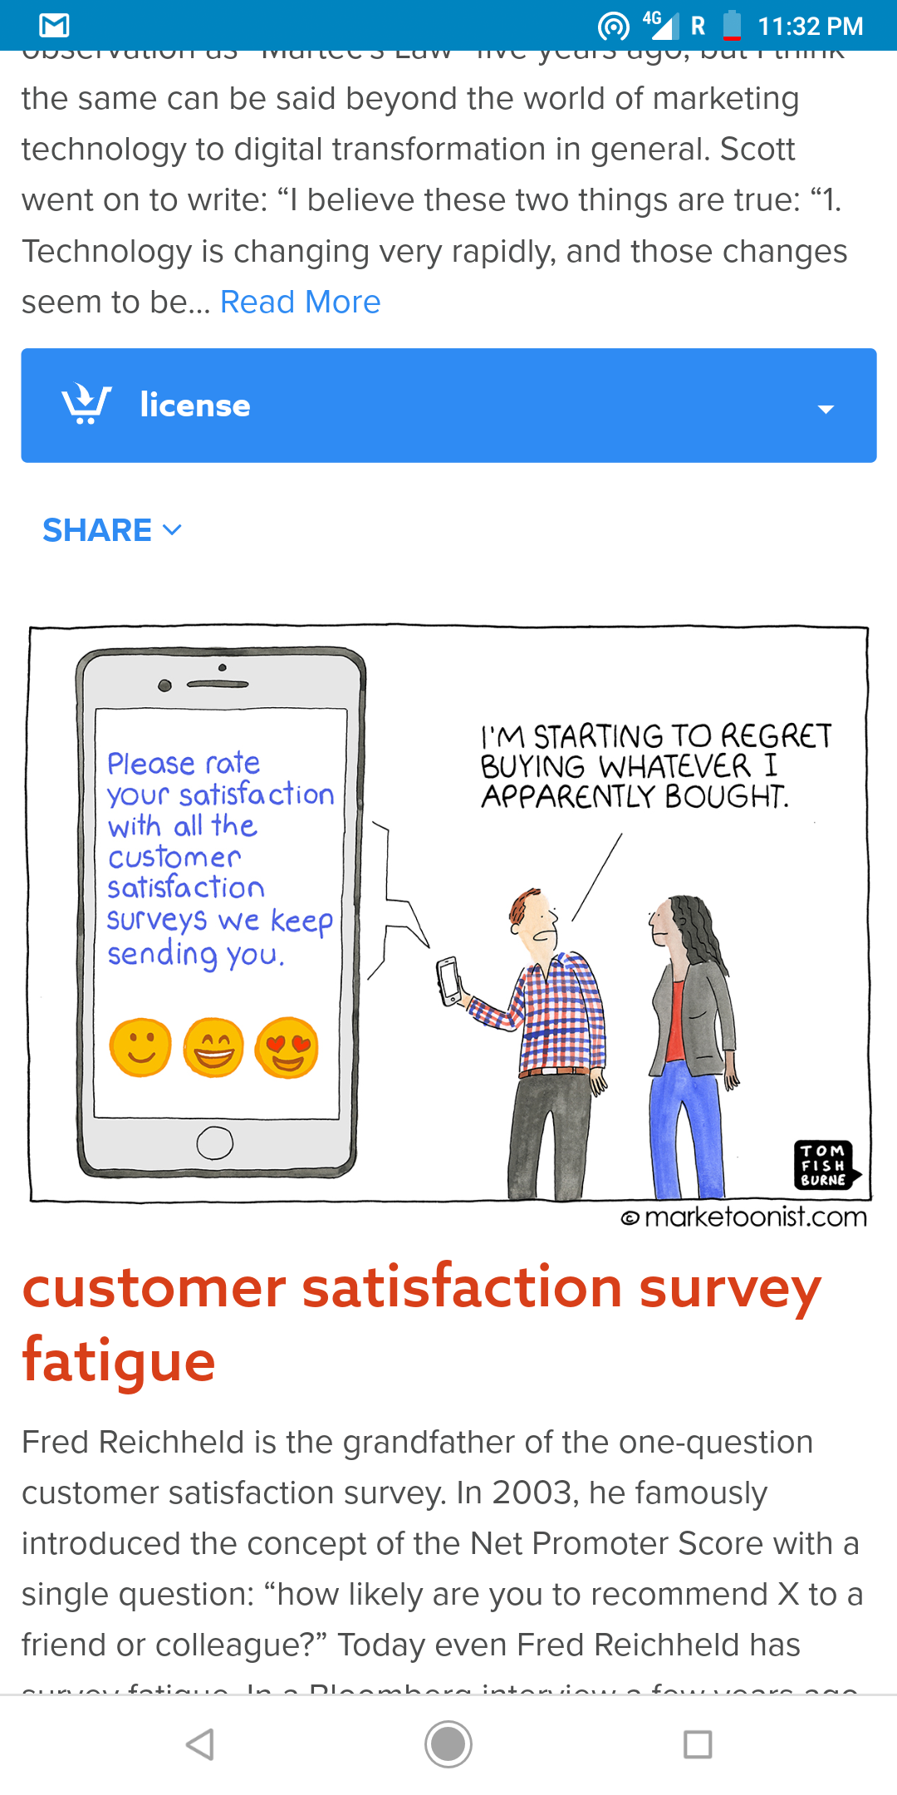

**Learning and Experiences:**

In pursuit of this project, I got a chance to apply all my learnings gathered over the course of my studies at NID. But it is after doing that I realise the learnings I accumulated after this experience has given me a lot think about in terms of my future as an independent practitioner of design battling the grounds of the real world.

Working in a bank, a 150-year-old bank as daunting as it sounds was not. The spirit and ethos with which the first ever design team in-house was formed gave me the drive to work harder. I am so glad I got to be part of this first-ever team who envisioned a future for the bank that will help it to transform for growth.

With firsts, come to a lot of firsts, if the prospect was exciting the challenge was greater. Chalking out a path for digital transformation for an industry that is still largely traditional was no small feat. From making sense of the enormity to the challenges of geographies and languages this project has been a roller coaster ride. It has taught me to be more rigorous in my approach and pushed my knowledge of service design, system design and design thinking to new heights.

Although there was a certain direction, the open brief helped me chalk out my own path. But with open briefs come bigger challenges. I had to set my pace, objectives, outcome and impact for a huge subject in a mere 4-5 months. The deliverables in such a project are more of the intangible nature and to make sure they are impactful was a constant challenge.

This project got me opportunities to test out my abilities in live projects that would help me on the way to validate my design principles and practice and more importantly brought me face to face with the challenges - legacy processes, big teams, slow pace, multiple stakeholders, shifting timelines etc.

To sum it up I have learnt how design can make an impact in a traditional sector like banking.

Source: http://mz.wtf/map/